Unsatisfactory Academic Progress Procedure  Immediate Withdrawal  Enquiries: research@yorksj.ac.uk | 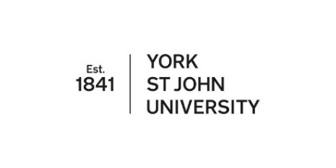

This form should be completed to recommend to Research Degrees Committee that a PGR be required to withdraw from their studies with immediate effect in accordance with section 10 of the Code of Practice for Research Degrees. Please return the form to Registry (research@yorksj.ac.uk)

Candidate’s full name: |  | Student number:
Degree: |  | School:
Main Supervisor:
Co-supervisor(s):

Consultaton Process:
Please provide brief details of the arrangements followed by the School in reaching this recommendation together with the names of the individuals within the University/School consulted and whether they are in agreement with the recommendation.

Grounds for the recommendation of immediate withdrawal (please complete all of the sections below and attach supporting documentary evidence to the form:
Please summarise the evidence that serious concerns about academic progress have been made in writing to the PGR over a prolonged period of time (4 months or more). Copies of relevant documentation should be attached to the form (eg. progress reports, supervisory meeting notes, emails, letters)
Please outline the support mechanisms made available to the PGR to address the concerns outlined in above (eg. this might be in the format of progress reports, supervisory meeting notes, emails, letters)
Please explain why it is not possible for realistic targets to be set and the PGR granted a further opportunity to improve progress under the Unsatisfactory Academic Progress Procedure

Authorisation:
School Postgraduate Research Lead
(or School Research & Knowledge Transfer Lead) signature:
Date:

Please attach copies of the relevant documents referred to above and send the form to Registry (research@yorksj.ac.uk).

