Guide to Making Notes
Study Development Factsheet

Making useful, well-organised notes is a crucial skill to master during your time at university. Your notes should aid your understanding of the topic, and will serve as a useful resource when you refer back to them in the future in order to help with completing your assignments and revising for exams. However you decide to capture your notes, the most important thing is to find a system that works for you.

What are the benefits of making notes?
- Improves your focus when reading.
- Promotes active learning and boosts understanding of material.
- Helps retention of important knowledge in the long-term.
- Serves as a resource for revision and use as evidence in essays.

What should I make notes on?
It is a good idea to make notes during your lectures, as well as any meetings with academic tutors. When reading books or articles, consider why you are reading that particular source, and think about what you are trying to achieve. If you are reading for general interest or preparing for a seminar, try to read widely on the topic and write down, in your own words, your understanding of the main ideas and areas of debate within the topic. If you are reading to find evidence for an assignment, read sources in more depth and pick out key arguments and statistics, and either quote them down directly or paraphrase the writer’s point of view in your own words. In general, remember to keep track of useful points from your research – don’t try to record everything!

What templates can I use for making notes?
There are a number of different templates or formats you can use to make your notes, and the approach you take may differ depending on the kind of research you are doing. There is no single ‘best’ way to make notes; the most important thing is that you find a method that works for you. The following methods are mainly designed for making notes with pen and paper, but there are also digital tools available such as MindView and Glean which can help you to capture notes in digital format; visit the Assistive Technology page on the Library website for more information.

Mind Map Method
MAIN TOPIC
SUB-TOPIC 2
Idea / quote 3
Idea / quote 4
SUB-TOPIC 1
SUB-TOPIC 4
Idea / quote 1
Idea / quote 2
Idea / quote 7
Idea / quote 8
SUB-TOPIC 3
Idea / quote 5
Idea / quote 6

The Mind Map method is useful for visualising, on a single page, the most important ideas within a particular area and seeing how they are connected. The idea is to start with the main topic in the centre of the page, then break this down into a number of sub-topics (you could think of this like a “table of contents” for a book about that topic). Then, for each sub-topic, you can make notes on key ideas, quotes, or definitions within that field. You may then spot ideas in different sub-topics that are connected in some way (e.g. ideas 4 and 7 in the diagram); making these connections will develop your critical thinking skills and add depth to your academic writing.

Box Method
MAIN TOPIC
SUB-TOPIC 1
SUB-TOPIC 2
Idea / quote 1
Idea / quote 2
Idea / quote 1
Idea / quote 2
SUB-TOPIC 3
SUB-TOPIC 4
Idea / quote 5
Idea / quote 6
Idea / quote 7
Idea / quote 8
The Box Method is similar to the Mind Map method; it is a way of breaking down a topic into different areas. The main difference is the way it is laid out on the page; the sub-topics are contained within their own sections. This can be a useful method to use when each of the sub-topics are mostly unrelated to each other, and you want to compartmentalise the key information.

Flow Based Method

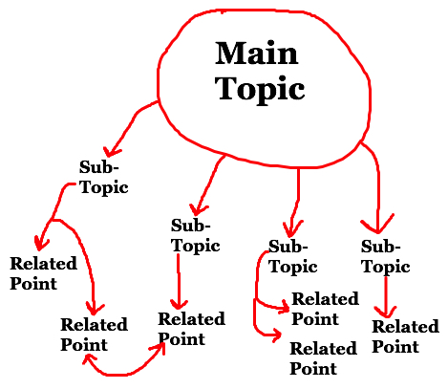
The Flow Based Method is another way of breaking down a main topic into various sub-topics. This approach differs from the Mind Map Method as it is less rigid; the idea is to explore a topic in a ‘free flow’ way, making connections and observations as you make your notes. This method may help you to clarify your thinking and make sense of a complicated topic with lots of overlapping, inter-connected ideas.

Cornell Method
Keywords & questions

Title / Reference
Main notes
Summary
The Cornell Method is a popular way of capturing notes during lectures, meetings, or about a particular academic source. Divide your page into four areas: a top banner for a title (this could be the date and topic of your lecture, or the title of a book or article); a section on the left for keywords and questions that arise as you are reading or listening; a large section for your main notes, where you may want to capture important ideas and quotes; and a section at the bottom of the page to summarise, in your own words, what you have learned.

Support: Study Development offers workshops, short courses, 1 to 1 and small group tutorials.
- Join a tutorial or workshop on the Study Development tutorial and workshop webpage or search ‘YSJ study development tutorials.’
- Access our Study Success resources on the Study Success webpage or search ‘YSJ study success.’

