Accident, Incident and Near Miss Reporting

In the event of an accident, incident or near miss in your workplace, area of study or anywhere within the University, please carry out the following:
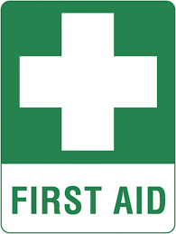
- If needed, Call a First Aider (01904 87 6444)
Security Officers - All Security Officers are First Aid trained and available 24 hours a day.
Lord Mayor’s Walk - Speak to Reception in the main building and a First Aider will be provided.
Haxby Road -Speak to Reception in the main building and a First Aider will be provided.
London Campus - Speak to Reception and a First Aider will be provided.

- Always report the Accident or Incident to your line manager or lecturer, as soon as possible.
- Help them to complete a University Accident or Incident Form. This should record full details and the action that can be taken to prevent reoccurrence.
- The Accident or Incident Form is online and found via the Health and Safety Pages
- Any questions, contact the Health and Safety Adviser.

