Notification of Withdrawal
  - User guide – Notification of Withdrawal (Student)

Student task

Overview
This online process has replaced the previous paper forms for the Notification of Withdrawal process. It can be found on eVision under the Change of Circumstances tab alongside other changes in your modules of programme of study.
The most important part of this process is discussing any changes with your course lead, academic tutor, or other university contact e.g. PASS or Student Records. This form should not be the first point at which your intention to suspend is raised.

Screenshots
- Notification of Withdrawal is clicked. If a request already exists but has not been approved yet, then a review screen will be shown (see step 5). If there are no open requests, then it will continue to step 2.
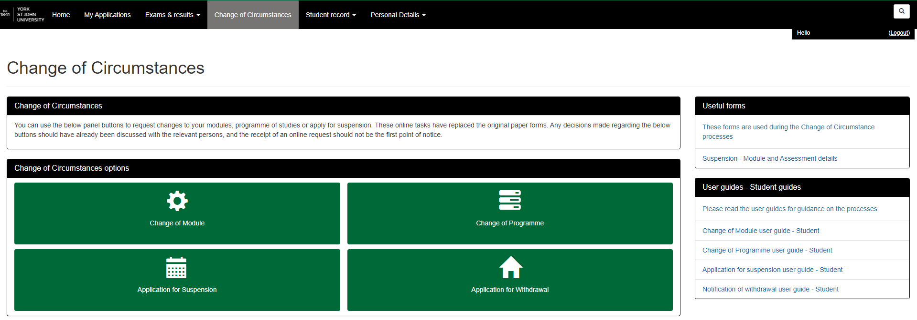
1

- The top section below displays your current programme/course details, if there are any errors or discrepancies then please contact Student Records. Please read the guidance at the top of the page carefully and follow the links to more information where applicable. The rest of the page is for recording details of your withdrawal. Please note updating your address for future correspondence will update your recorded home address in SITS.
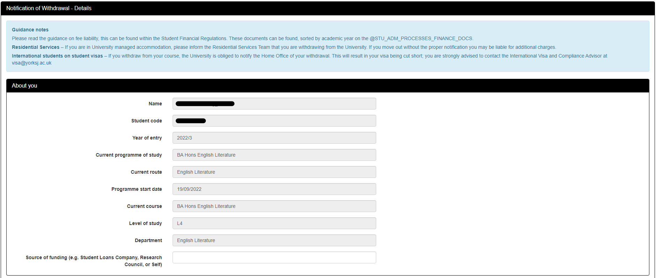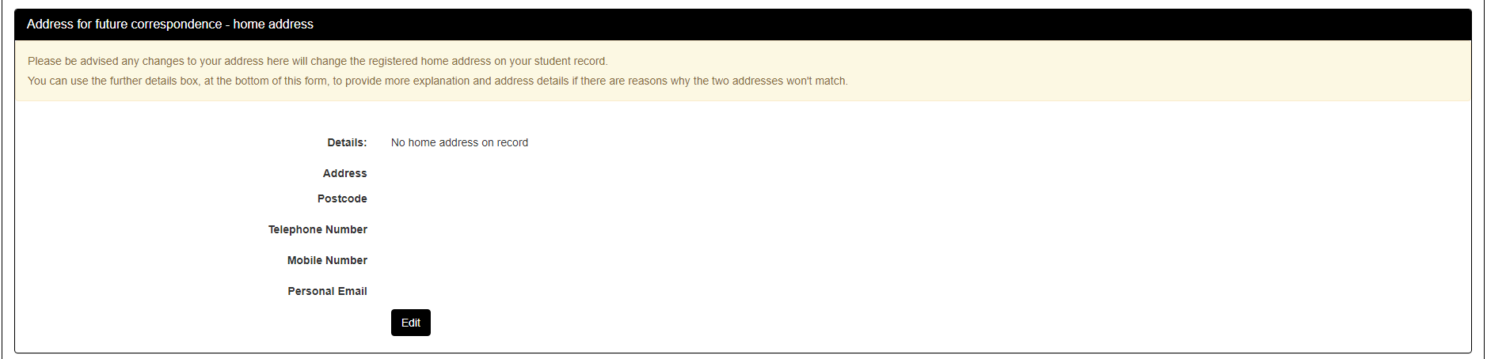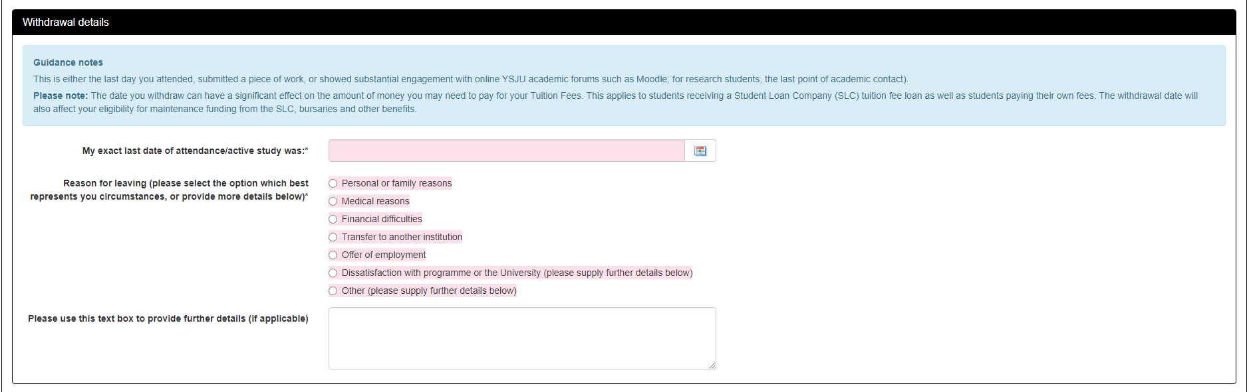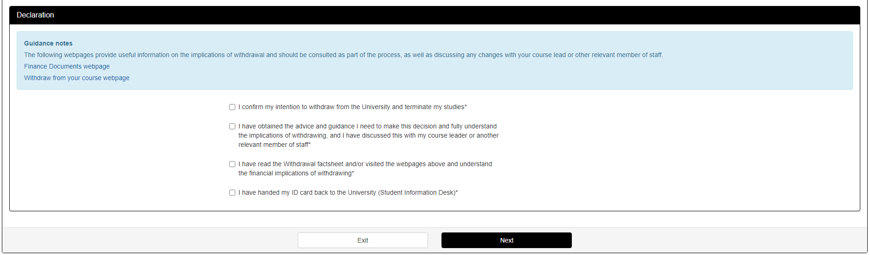
2

- Clicking Next will show the review details page below. If any changes need to be made please click Back, otherwise clicking Submit will send the details of the request to the indicated approver.
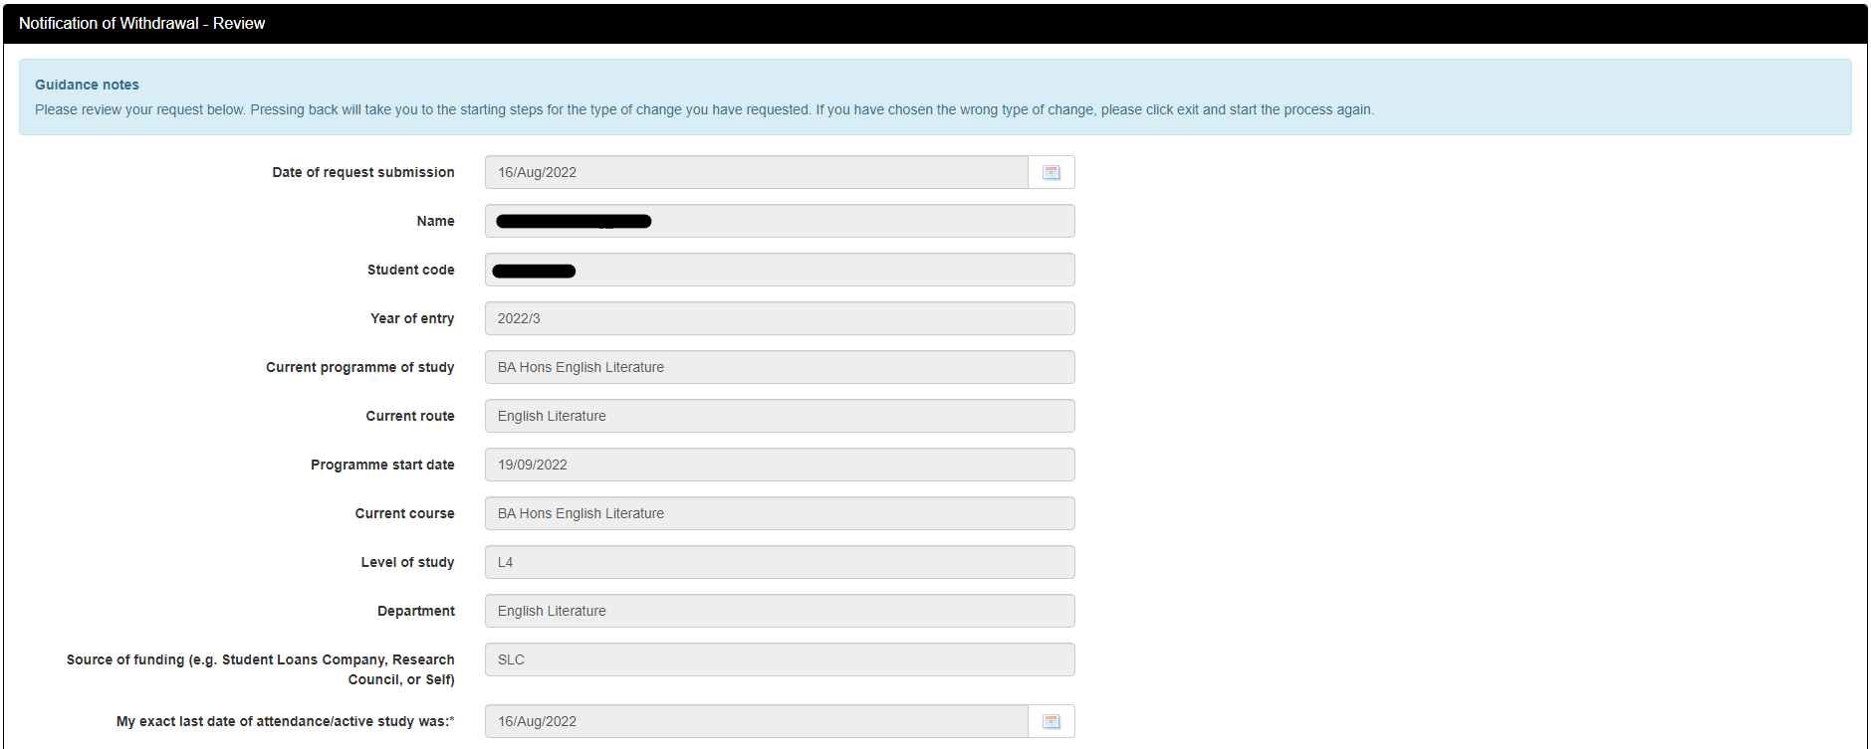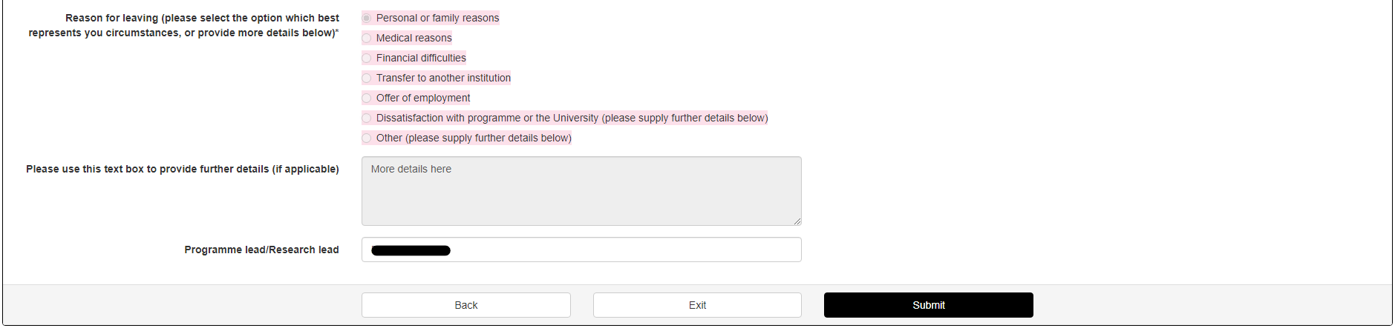
3
- The final page indicates the request has been submitted. An email of the details is sent to your home and contact email addresses.
4

- If an open request, not yet approved exists then the following screen will be shown detailing what has been submitted previously. If you wish to amend any details then pressing Edit will take you back through the process above, and completing the process will save the new details.
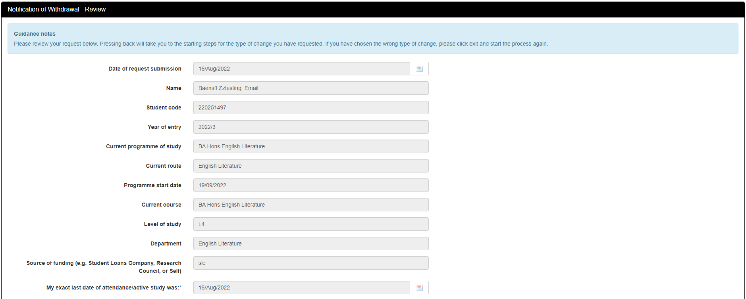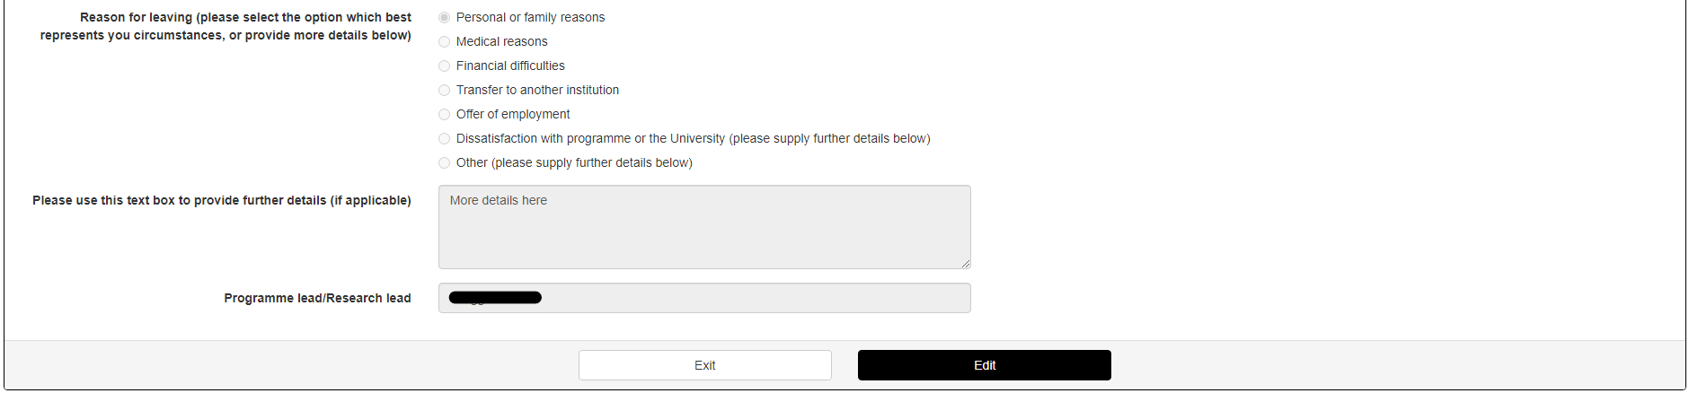
5

