Reflective Writing
Study Development Factsheet

We are often asked to think ‘reflectively’ on our experiences, and to demonstrate our reflections in a reflective essay. Several models are used to help structure our reflections, but we also need to remember why we are being asked to reflect on our actions to begin with.

Why reflect?

Reflective writing is about contextualising and questioning your experiences. A reflective essay isn’t just about the final assignment; the process of writing helps you to achieve a better understanding of your decisions and feelings, so you improve your practice in the future.

Reflective thinking also helps you build connections between theory and practice. You will often be asked to engage with theory, research and professional guidance to help you bridge the gap between your individual experiences and the situations in which those experiences took place. Critical thinking is at the heart of reflection – in the same way you question academic sources, question your own experiences.

Reflective models

There are many models that can help to structure your reflection. Most of these take the shape of a cycle, but they all share the idea that reflection should evaluate a specific experience and communicate specific lessons that can be learned from it. Widely-adopted models include Gibbs (1988) reflective cycle and the CAR (Context-Action-Result) and ERA (Experience-Reflection-Action) methods, but two of the most prominent models are in Kolb (1984) and Driscoll (2007).

Cycles
Driscoll’s model has three stages, each beginning with a simple ‘what’ question:
- What? 2. So what? 3. Now what?
Kolb’s model has four stages:
- Concrete experience 2. Reflective observation 3. Abstract conceptualization 4. Active experimentation.
Gibbs model has six stages:
- Description. 2. Feelings. 3. Evaluation. 4. Analysis. 5. Conclusion. 6. Action plan.

Source: David Kolb (1984), Experiential Learning: Experience as the Source of Learning and Development. Upper Saddle River: Prentice Hall.
Source: John Driscoll, ed. (2007), Practicing Clinical Supervision: A Reflective Approach for Healthcare Professionals. Edinburgh: Elsevier.
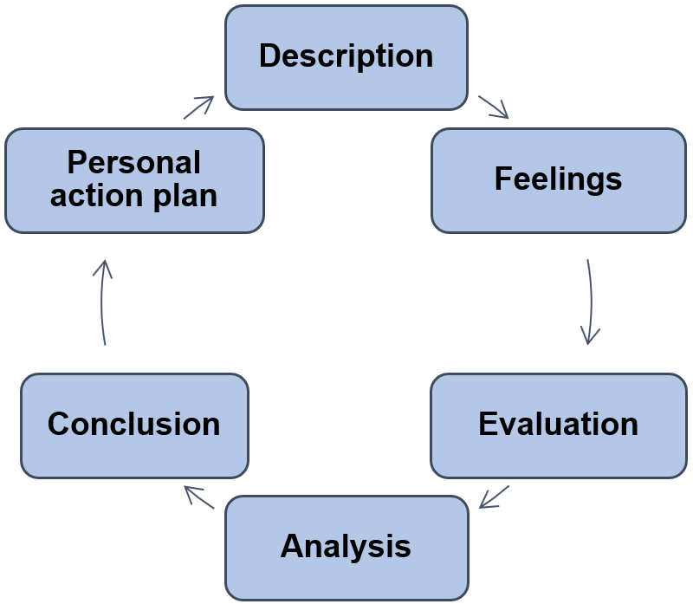

Source: Graham Gibbs (1988), Learning by Doing: A Guide to Teaching and Learning Methods. Further Education Unit.

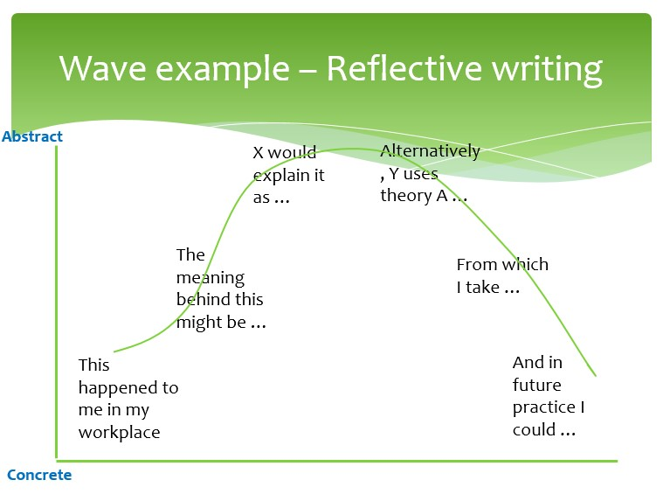
Waves

A useful alternative to the reflective cycle is the
reflective wave. The idea here is that reflection
should surf a wave from concrete to abstract and
then come back down again. In other words, we
distinguish between waving ‘up’ from experience
to theory and waving back ‘down’ from theory to
our practice.

Source: Ian Johnson (2020), ‘The best way to surf the reflective wave?’ ALDinHE. https://aldinhe.ac.uk/take5-39-the-best-way-to-surf-the-reflective-wave/

Can I say “I”?
Example paragraph
While listening to my client’s romantic dilemma, I found myself feeling judgemental towards her: I could not relate to the fact that she was breaking up with her partner just because he was not from the same social milieu. My supervisor helped me realise that, while I pride myself on valuing people from all cultures equally, I actually harbour strong prejudice against the upper classes. This prejudice stopped me from appreciating my client’s’ ‘internal frame of reference’, which Nelson-Jones (2008) stresses is key to an effective counselling relationship. As Rogers (1968) highlighted, while it may not be possible to completely put ourselves in other people’s shoes, ‘unconditional positive regard’ is a core condition of therapeutic work, whereas a judgemental attitude hinders progress. I therefore need to focus on prizing my client as an individual, regardless of her values and choices.
Unless you are told to do otherwise, yes!
Reflective writing demands that you look
within and discuss your experiences, thoughts and feelings. Avoiding ‘I’ can obscure these personal elements and lead
to confusion: for example, if you’re reflecting as a trainee teacher on placement, referring to what ‘the teaching practitioner decided’ could wrongly suggest you’re describing another member of staff’s actions rather than your own. Saying ‘I decided…’ resolves this uncertainty because it clearly signals that the person you’re discussing is you!

Tip! See if you can map one of the reflective models onto this paragraph. This will help you see how it can be applied in practice.
Further Reading
- University of Cambridge’s Online Reflective Practice Toolkit.
- Driscoll, J. (2007). Practising clinical supervision: a reflective approach for healthcare professionals. 2nd ed. Edinburgh: Baillière Tindall Elsevie.
Print
- Gibbs, G.(1988). Learning by doing: a guide to teaching and learning methods. London: Further Education Unit.
Print
- Johns, C., ed. (2010), Guided reflection: A narrative approach to advancing professional practice. Chichester: Wiley Blackwell.
Ebook | Print
- Kolb, D A (2015). Experiential learning: experience as the source of learning and development. New Jersey: Pearson Education Ltd.
Print
- Williams, Woolliams and Spiro (2012), Reflective Writing. London: Palgrave Macmillan.
Ebook | Print
- YSJ’s Reflective Writing templates for Kolb, Driscoll, and Gibbs.
Support: Study Development offers workshops, short courses, 1 to 1 and small group tutorials.
- Join a tutorial or workshop on the Study Development tutorial and workshop webpage or search ‘YSJ study development tutorials.’
- Access our Study Success resources on the Study Success webpage or search ‘YSJ study success.’

