Personal Information and Consent Form
Community Language School | York St John Communities Centre

Part 1: Personal details of the child/ young person

Full Name:
Pronouns e.g. she, he, they
Date of Birth:
Gender:
Nationality:
Address:
Please indicate which language class you would like your child to attend:
Does the child/young person have any specific or additional needs? e.g. accessibility, communication
Does the child/young person have any disabilities you would like to make us aware of?
Does the child/young person have any medical conditions or allergies that we would need to be aware of in the event of an emergency? Please advise if your child takes any regular medication we may need to be aware of.

Part 2: Emergency Contact Information

Emergency Contact 1 | Mother, Father or Carer
Full Name:
Telephone:
Email:
Address:
Relationship:
Is this person permitted to collect the child/young person after class from the YSJ Campus in York? | Yes/No
Is this person able to converse in English or would they require an interpreter? if so, please advise on Language spoken.

Emergency Contact 2
Full Name:
Telephone:
Email:
Address:
Relationship:
Is this person permitted to collect the child/young person after class from the YSJ Campus in York? | Yes/No
Is this person able to converse in English or would they require an interpreter? if so, please advise on Language spoken.

Other Designated People
Please indicate if there are any other designated people who are permitted to collect the child/young person from the YSJ Campus in York. (Please include name and relationship).
Full Name:
Telephone:
Relationship:

Full Name:
Telephone:
Relationship:

Part 3: Further Information
No Parking Policy
There is no parking available on the Lord Mayor's Walk campus, other than for Blue Badge Holders who have been issued a permit. There is a 15 minute 'grace' period for the purposes of drop-off and pick-up. For this no permit is needed, but cars should be parked in the bays marked 'Loading' - there is one outside Fountains Learning Centre and one outside St Anthony's House: as indicated by the blue lines on the image below:
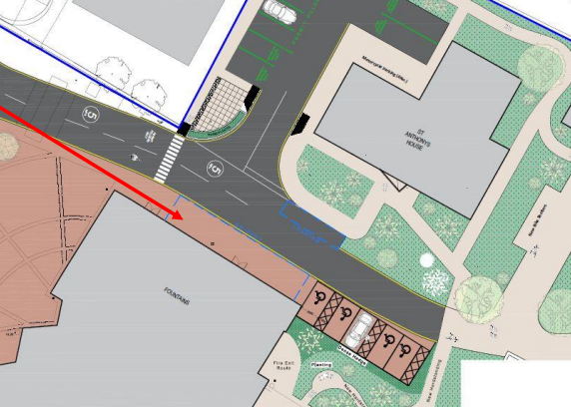

Entering University Buildings
When arriving at the University, please ensure your children walk with you. Some of our fire safety doors can be heavy and difficult for children to open. Also, as the University is used by the public for other events and programmes, it’s important that children stay with you at all times outside of class.

Classroom Safety
To help keep everyone safe, please remind your children not to climb on chairs or crawl under desks. This helps prevent accidents and injuries and supports our volunteer tutors in managing the classroom.

Use of University Equipment
Devices such as smartboards, computers, and projectors are for staff use only. We kindly ask that children do not use this equipment, and we appreciate your help in reinforcing this rule.

Our School’s Purpose and Research
This school was launched to meet a long-standing need identified in research: supporting migrant, multilingual families in maintaining their home languages. Our academic team leads research in this area and in related ones. So, from time to time, we will invite you and your children to take part in research projects as your participation would help us make valuable contributions to both the academia and the wider community.

Voluntary Donation Scheme
To help cover the school’s routine operational costs, we have a voluntary donation scheme via an online store. You can choose to make weekly or one-off donations here: https://store.yorksj.ac.uk/product-catalogue/schools-departments/health-life-sciences/ysj-communities-centre-cls-donation

Part 4: Privacy Notice
All personal information gathered and held by York St John University is treated with the care and confidentiality required by the General Data Protection Regulation (UK GDPR) and the Data Protection Act 2018. For further information, please visit Data protection | York St John University

Who are we?
The data controller is York St John University, Lord Mayor’s Walk, York, YO31 7EX. The University’s Data Protection Officer is the PVC Governance and Student Life, York St John University, Lord Mayor’s Walk, York, YO31 7EX, tel: 01904 626844 , email: gov.compliance@yorksj.ac.uk.

What legal basis do we have for processing your personal data?
By completing and submitting the form, you are giving us your consent to process the personal data provided. The processing of personal data is covered under UK GDPR Article 6 (1)(a) where processing is based on consent and the controller shall be able to demonstrate that the data subject has consented to processing of their personal data. You have the right to withdraw your consent at any time and can do so by emailing the University at gov.compliance@yorksj.ac.uk.

How long do we keep your personal data?
We will retain your data for the entire period that the child/young person engages within the Community Language School and for a further 5 years after disengagement.

Any questions or concerns?
If you have any questions or concerns about the way we are collecting and using your personal data we request that you contact us at York St John University, Lord Mayor’s Walk, York, YO31 7EX, email: gov.compliance@yorksj.ac.uk, tel: 01904 624624.

Part 5: YSJ Communities Centre’s Community Language School - Consent Declaration
The York St John Communities Centre’s Community Language School offers classes in languages other than English to children from families in York and surrounding areas. Classes take place on Saturday afternoons on the main YSJ Campus in York. Please note that classes cannot be offered on days where the University requires the rooms for other events. Therefore, please ensure to check the term dates on the calendar provided with this form.

I give my consent for my child (name:)………………………………………. to participate in the York St John Communities Centre’s Community Language School. I also agree to the above privacy notice.

Name of Parent or Carer | Signature | Date

Please email the completed form to cls@yorksj.ac.uk

