Note Nuggets

Study Development Worksheet

**Note Nuggets is a note-making tool for building knowledge and understanding of a topic.**

A nugget is one piece of information that you have written down. Each nugget explains one aspect of a subject, and by adding more, you can use this to build an understanding of the topic. Aim to write a maximum of 100 words for each nugget.

Note nuggets can be used to capture key information about a subject or help you organise your ideas. This worksheet template will help you apply this note-making tool.

**Example.**

**Topic: Reflective writing**

**Nugget One: Nugget Two:**

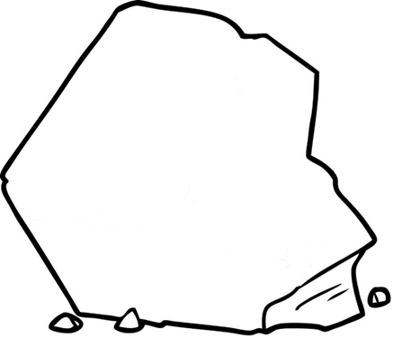



* **Summarise the origin and historical developments of reflective writing.**
* **How is it used in contemporary times?**
* **Define reflective writing.**
* **Identify the purpose of reflective writing.**

**Nugget Three: Nugget Four:**



* **What are the strengths and limitations of the reflective model?**
* **What scenarios can you use this model?**
* **Name one theorist and sum up their reflective writing model.**

**An example of making Note Nuggets is on a reflective writing topic.**

**Nugget One: Nugget Two:**





John Dewey, an educational reformer in 1910, created the term reflective practice.

Educational theorist Donald Schön, in 1983, proposed that reflection has two components: reflection-in-action and reflection-on-action.

**N.B. Include further timelines to build a historical understanding of a topic and its developments.**

Reflective writing is defined as thinking in-depth about an experience, including personal feelings at the time, strengths and weaknesses, and any theoretical or practical ideas in order to identify future actions needed.

The purpose of reflective writing is to learn from an experience.

**N.B. Include a definition quotation, as this can be used as evidence to support your explanation.**

**Nugget Three: Nugget Four:**



Strengths of this model:

* A strength of Rolfe’s Reflective Model is that it is accessible and simplistic to use.
* This model proposes an effective framework where the learner can evaluate their experience and link theoretical ideas.

This model can be used to reflect on practical activities.

Rolfe et al.'s (2001) Reflective Model has three stages: What? So what? Now what?

* The **What?** part describes an experience.
* The **So what?** part is analyses the experience and links a theory or academic literature.
* The **Now what?** part reflects on what has been learned and what future actions are needed.

Bibliography

Rolfe, G., Freshwater, D., Jasper, M. (2001) Critical reflection in nursing and the helping professions: a user's guide. Basingstoke: Palgrave Macmillan.

Use this blank worksheet to build your own note nuggets!

­­­­­­­­­­­­­­­­­

**What is the topic? _____________________________________**

**Nugget One: Nugget Two:**



**Nugget Three: Nugget Four:**



**Support:** Study Development offers workshops, short courses, 1 to 1 and small group tutorials.

* Join a tutorial or workshop on the [Study Development tutorial and workshop webpage](https://www.yorksj.ac.uk/library/library-study-and-digital-skills/study-development-tutorials/) or search ‘YSJ study development tutorials.’
* Access our Study Success resources on the [Study Success webpage](https://www.yorksj.ac.uk/students/study-skills/study-success/) or search ‘YSJ study success.’