Public Speaking Anxiety
You may have assessments that involve public speaking. These could be individual or group-based, recorded or live, planned or guided. Your speaking may be supported by visual aids, like academic posters, or take different forms such as podcasts or business pitches.
For some people, public speaking can feel exciting and an opportunity to share their ideas. However, for some, it may trigger anxiety or fear. This anxiety may lead people to avoid public speaking situations or delay preparing for them. It may also cause uncomfortable physical symptoms such as breathlessness, a dry mouth, sweating, an increased heart rate or brain fog.
Why Do I Get Anxious?
- If you have Social Anxiety Disorder, you might be more likely to feel anxious during presentations.
- Some people experience Glossophobia, a specific fear of public speaking.
- You may have had a negative experience in the past causing your brain to fixate on this.
- Presenting may feel unfamiliar and uncertain if you’ve only done written assignments.
- You may worry about your performance or the emotions you experience while speaking.
- You may worry about the reaction from the audience.

Helpful tools and strategies
Prepare!
Feeling unprepared is a common source of anxiety, so taking time to prepare for your public speaking can help you feel more confident and in control.
- Read the brief and highlight key areas.
- Think about the audience, the format, the tone and the purpose.
- Break down your presentation into manageable sections, such as the introduction, your main points and your conclusion
- Look at the duration and assign strict time limits.
- You may be expected to invite the audience to ask questions, and this fear of the unknown or being put on the spot can cause anxiety. Think about what questions an audience may ask you: Are there any concepts they’d like you to explain further or points they might question? Do they want deeper insight into your opinions?

Practice!
- If your presentation has a time limit, practice speaking out loud and time yourself to make sure you stay within the allowed timeframe.
- Write bullet points or sentence starters on cue cards to guide your speech. Practice using them as prompts rather than reading directly from them, to help your delivery feel more natural.
- You can build confidence by gradually exposing yourself to public speaking situations. This involves taking small, manageable steps that help train your mind to see the experience as safe. Over time, this aims to reduce fear and makes speaking feel less intimidating. You could practice on your own, practice in front of a mirror, record yourself or practice in front of a trusted person.

- Identify what causes you anxiety about presenting and rate how strongly you feel it.
- Come up with a list of situations you could use to practice facing that anxiety, and arrange them in order from least to most intense.
- Work through each situation starting with the least intense, and rate your anxiety before, during and after.
- Practice repeatedly until your anxiety decreases before moving on to the next level.

It is important to not put yourself in situations that will make you feel uncomfortable, so contact the Wellbeing Team to receive guidance, or come to Study Development’s SpeakEasy, which is a safe and supportive environment for students and staff who want to develop their public speaking skills.
Example:
I am anxious about presenting in front of a group of people
Situation (least intense to more intense) | Anxiety rating before | Anxiety rating during | Anxiety rating after
Practise on my own
Practise in front of the mirror
Record myself
Let someone I trust watch the recording
Practise in front of 1 trusted person
Practice in front of a small, trusted group

Self-soothing techniques
If you practice speaking and it brings up feelings of anxiety, you can do something to sooth yourself to decrease the anxiety:
Practice breathing exercises: Breathing plays a key role in managing anxiety symptoms. Try practicing these breathing exercises leading up to your presentation:

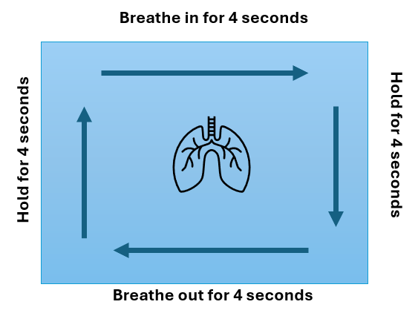
Diaphragmatic breathing: When we feel anxious, our breathing often shifts to our chest and shoulders rather than using our diaphragm. To check this, place one hand on your chest and the other on your stomach, and notice which hand moves as you breathe. To calm ourselves, we want to shift away from shallow chest breathing and engage the diaphragm. As you breathe in, aim to feel the hand on your stomach rise. Hold your breath for about 5 seconds, then exhale slowly and feel your stomach gently fall.
Box breathing: this technique helps you concentrate on your breath in a calm, even rhythm. As you breathe, picture the outline of a box in your mind: Inhale for 4 seconds → Hold for 4 seconds → Exhale slowly for 4 seconds → Hold again for 4 seconds→ Repeat
Try using visualisation techniques to imagine yourself finishing the presentation confidently and feeling successful. Take a moment to define what success means to you. Is it simply getting through the presentation? Or is it having the audience engage with thoughtful questions afterward?
Have something to ground you, such as something small in your hand, something to fidget with, or picking something in the room to focus on.
Challenge your mindset when you find yourself having a negative thought about your presentation. Pause, write it down, then look to challenge it by asking yourself what evidence supports this thought, what evidence is against it, and are there other possible explanations. Finally, reframe the thought into something more balanced and positive.
For example:
Negative thought: "If I make a mistake, I will fail”
Reframing of thought: "Mistakes are part of learning, and it won’t define my whole presentation”
Remember, this situation is temporary, and it will pass.

The bigger picture: It may be helpful to take a step back from your assessments and think about how public speaking could benefit you in the future. Strong communication skills are valuable in many workplaces and careers, so consider what skills you are developing through this assessment and how you can use them to support your future goals.

During the presentation
- Focus on your breathing using the previous breathing techniques.
- Hold something small in your hand to use as a grounding object.
- Pick something in the room to focus on.
- Have a drink of water.
- Open up your posture. Relax your shoulders, place your hands by your side, and feel the floor underneath you.
- When a question is asked, write down a few key words on paper to help you remember it, and take a moment to pause while you collect your thoughts.

After the presentation
- Take a moment to congratulate yourself! You did it!
- If you still have excess adrenaline or anxiety, drink some water, move your body and take some deep breaths.
- Treat yourself to something enjoyable as a reward.
- Reflect on the experience. What went well? Is there anything you’d approach differently next time?
- Be mindful of thinking too much about what happened or dwelling on any mistakes. Set boundaries for yourself, and remember, you’ve done your best.

