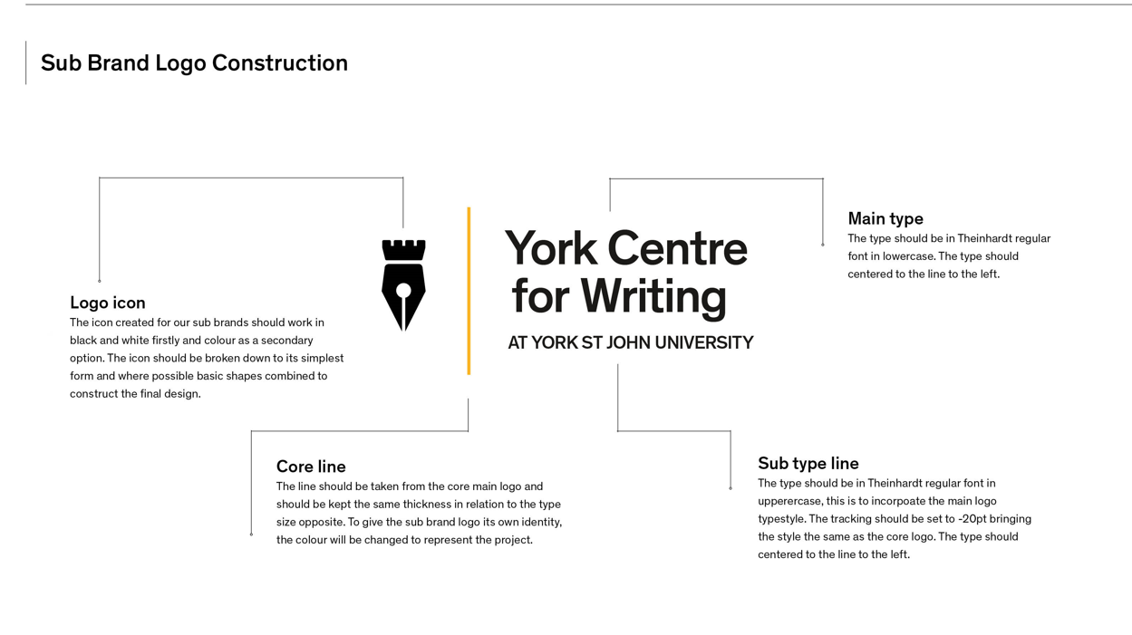
Example of the construction of a sub brand
19 July 2024
Image Description:
The logo includes:
- A black and white icon of a pen nib on the left
- A solide yellow dividing line to the right of the nib
- The words “York Centre for Writing” large on the right of the line
- The words “At York St John University” smaller underneath this on the right

There are explanations of the various elements of the logo, with lines showing which element they are referring to. These are, moving from left to right:

Logo icon
The icon created for our sub brands should work in black and white firstly and colour as a secondary option. The icon should be broken down to its simplest form and where possible basic shapes combined to construct the final design.
Core line
The line should be taken from the core main logo and should be kept the same thickness in relation to the type size opposite. To give the sub brand logo its own identity, the colour will be changed to represent the project.

Main type
The type should be in Theinhardt regular font in lowercase. The type should centered to the line to the left.

Sub type line
The type should be in Theinhardt regular font in upperercase, this is to incorpoate the main logo typestyle. The tracking should be set to -20pt bringing the style the same as the core logo. The type should centered to the line to the left.

