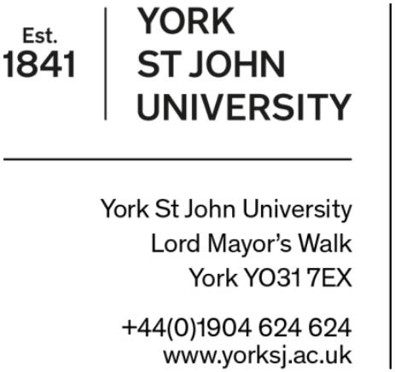

VISA DOCUMENT CHECKLIST

responsibilities

Students
They must cooperate with the University in fulfilling its Student Visa Sponsorship duties.

Visa Compliance Team
The team is required to act in accordance with Home Office policy. The team is responsible for overseeing the York St John University compliance with the Home Office’s Student Visa policy.

visa terms
Visa Vignette – this is a visa sticker in a passport and is received after making an entry clearance visa application.
UK Visa Entry Stamp: If you have your visa vignette (sticker) inside your passport, the immigration official at the airport will stamp it with the date you entered the UK. This then 'activates' your visa and ensures that Home Office UKVI record the date, location and the type of visa you used to enter the UK. Students who need immigration permission to study in the UK must provide the University with copies of their passport and visa(s) as part of their enrolment process. This includes a copy of the entry stamp. If you do not have an entry stamp because you entered the UK via an e-Gate, please upload evidence of travel such as your travel ticket/booking or boarding pass which confirms the date of your arrival in the UK.
E-Gate: Entering via an e-Gate means that your visa will not be endorsed with an entry stamp as the port is unmanned by Border Force staff. If you chose to use an e-Gate then you will be required to upload your travel ticket/booking or boarding pass in place of an entry stamp as evidence of your arrival in the UK.
BRP (Biometric Residence Permit) – It is evidence of your immigration permission for the full length of your course and any built in "wrap-up period". When a student applies for entry clearance, they are granted a 90-day visa sticker in their passport to use to travel to the UK. They then collect the BRP (with the full student visa details on it) after arriving in the UK. Their BRP is their visa for the duration of their studies. EEA nationals who use the UK Immigration ID check app do not collect a BRP. Their full visa is issued as an online digital status. Normally, you must collect your BRP within ten days of arriving in the UK, or before the end date of your vignette, whichever is later. You are likely to need it during your first few weeks in the UK, for example to arrange accommodation or to open a bank account. You should not travel outside of the UK until you have collected your BRP.

Sample of Stamped Vignette  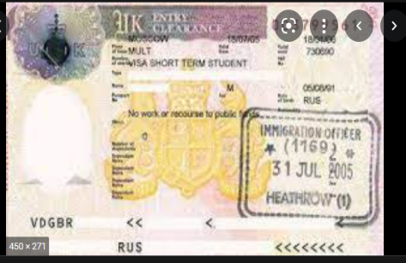 | Sample of BRP card  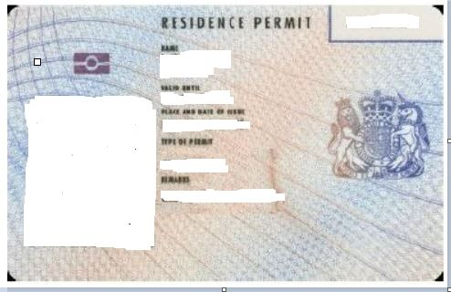

Useful Information | Things to consider
Prior to arrival | - valid passport  - Visa on arrival to the UK  - Evidence of funding  - A recent medical report including x-ray results (if required)  - Notification of CAS e-mail  - unconditional offer letter  - UKVI decision letter
On arrival in UK- Update your visa details | - Vignette together with UK Visa Entry Stamp  - Travel ticket/booking boarding pass, declaration of using E-gate
Collection of your BRP card | - Email visa@yorksj.ac.uk
Study at York St John University | As your visa sponsor, the University is required to act in accordance with Home Office policy  - Notify the Home Office if there is a change of circumstances with your studies, for example if you change course, intermit, stop studying prior to completion or you complete earlier than the course end date given in your CAS.

