1. Log onto e:Vision: <https://evision.yorksj.ac.uk/live/sits.urd/run/siw_lgn>

*If you experience difficulties accessing e:vision on a mobile phone, it is recommended that you use a PC or laptop instead. Open-access PCs are available in the* [*library*](https://www.yorksj.ac.uk/library/) *if needed.*

1. Navigate to the tab **Exams & results** and select **Exams** from the drop down menu. A screen shot of a computer

   Description automatically generated
2. Click on the timetable under the heading “**Personalised Examination Timetable**”

1. You will be taken to a new page where your personalised timetable should appear. If there are no details appearing in the report, then you will not have been included in any timetabled activities. If you think this is incorrect, please email [exams@yorksj.ac.uk](mailto:exams@yorksj.ac.uk)



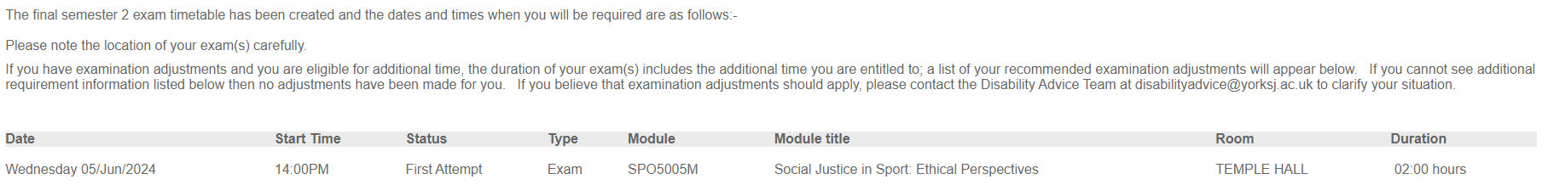

1. If you have an LAP (formally known as an LSP) that permits exam adjustments these will be listed beneath your timetable under the heading **Additional Requirement Information**.

Please email [exams@yorksj.ac.uk](mailto:exams@yorksj.ac.uk) if you think your exam adjustments are not correct.

If you cannot see the heading “additional requirement information” but believe you should have exam adjustments, please contact the Disability Support and Inclusion Team at [disabilityadvice@yorksj.ac.uk](mailto:disabilityadvice@yorksj.ac.uk) to clarify your situation.