Application for Suspension
  - User guide – Application for Suspension (Student)

Student task

Overview
This online process has replaced the previous paper forms for the Application for Suspension process. It can be found on eVision under the Change of Circumstances tab alongside other changes in your modules of programme of study.
The most important part of this process is discussing any changes with your course lead, academic tutor, or other university contact e.g. PASS or Student Records. This form should not be the first point at which your intention to suspend is raised.
If you are a research student, you will see slightly different screens. You can view your screenshots here.

Screenshots
- Application for Suspension is clicked. If a request already exists but has not been approved by an academic yet, then a review screen will be shown (see step 7). If there are no open requests, then continue to step 2.
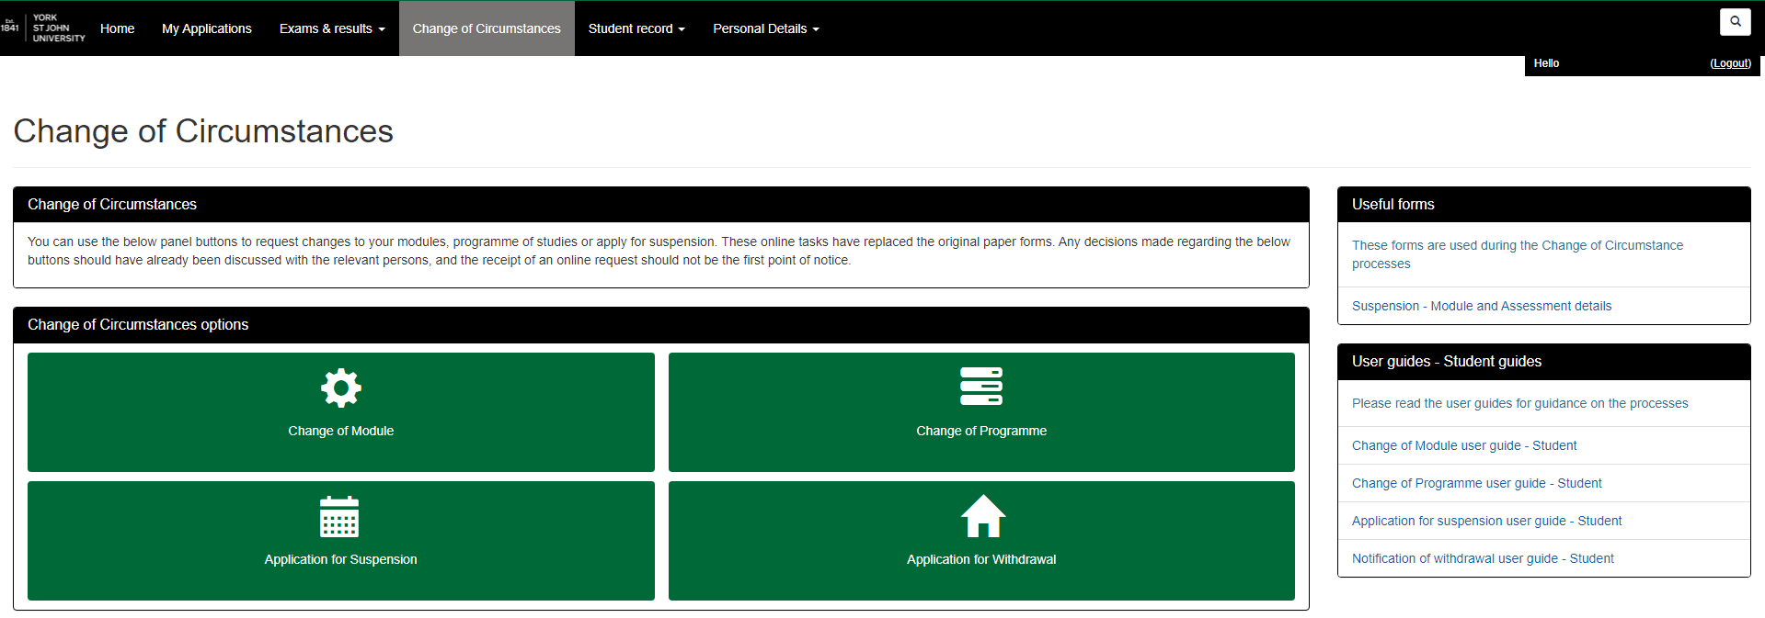
1

- Please read the guidance on this page, you can follow the links to find out more information about the process and access the University's policy documents. You must tick all the boxes even though they may not apply.
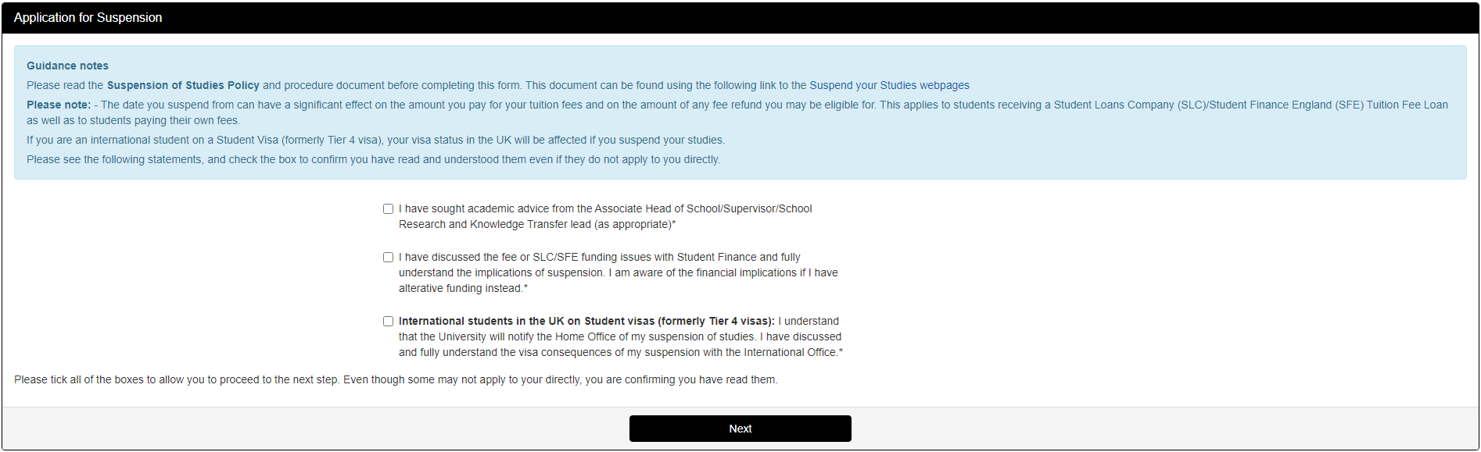
2
- This section above displays your current programme/course details, if there are any errors or discrepancies then please contact Student Records.
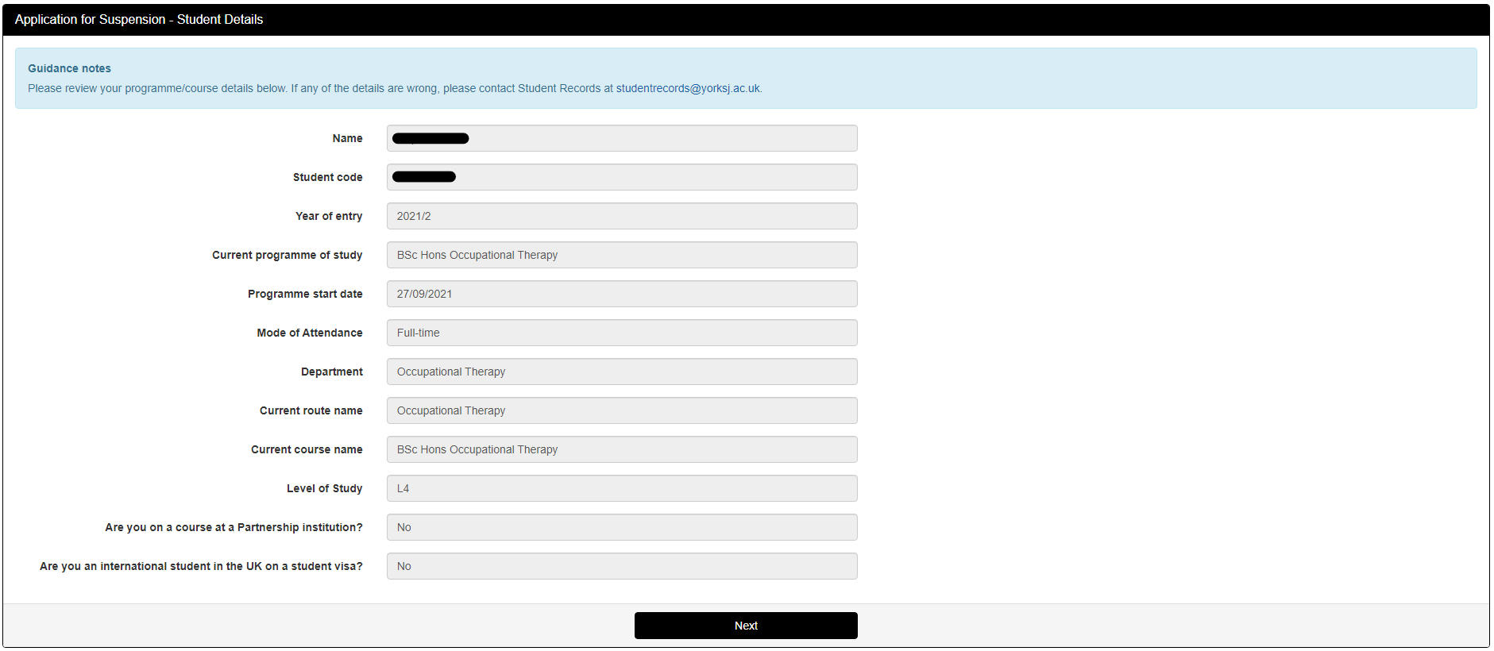
3

- The page below is for the main details of your request. Please read all the help text (in blue) and questions fully before completing the sections. If you are unsure of what to put for any section please discuss these with your course/programme lead or academic tutor in the first instance or student records.
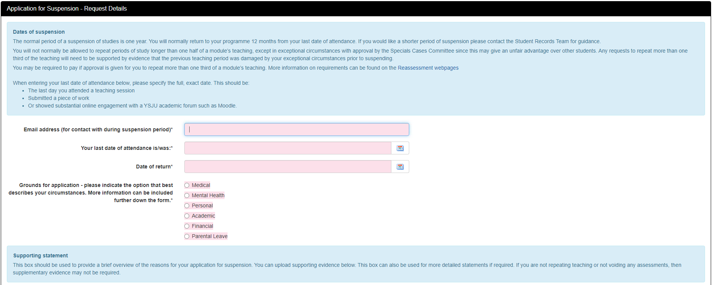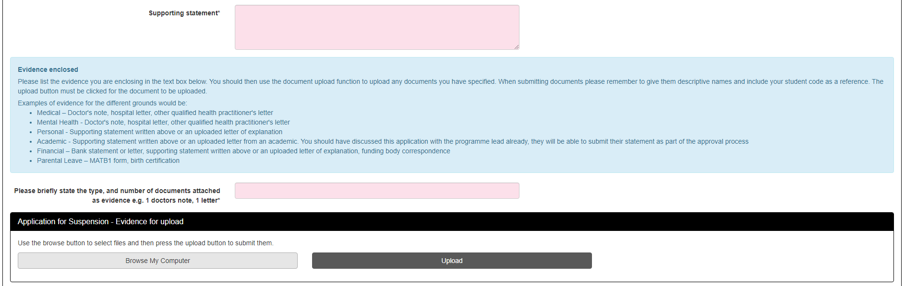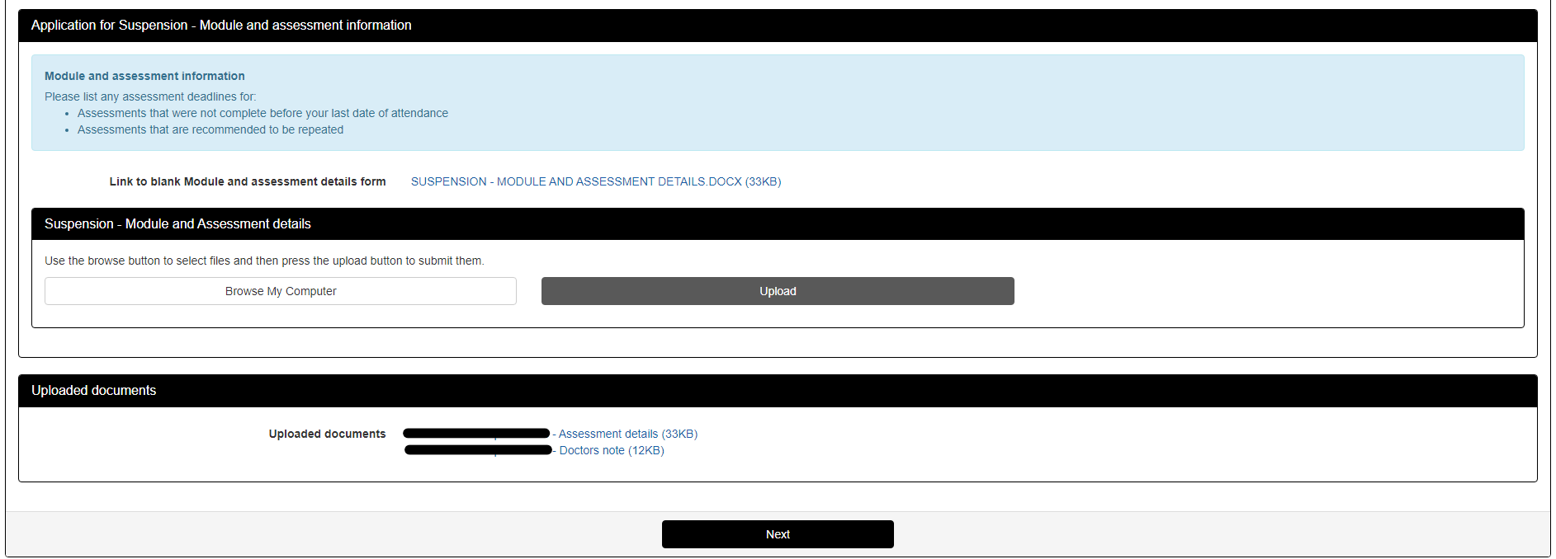
4
Only visible if editing an open request
Reminder – When uploading documents please give them descriptive names including your student code and name. The documents will not be uploaded unless you press 'Upload' before proceeding to the next step.
- The page shown below is a review of the information you have provided, if you notice any errors in what you have put, Clicking Back will take you back to the previous step. If you have uploaded incorrect files these can be deleted and re-uploaded.
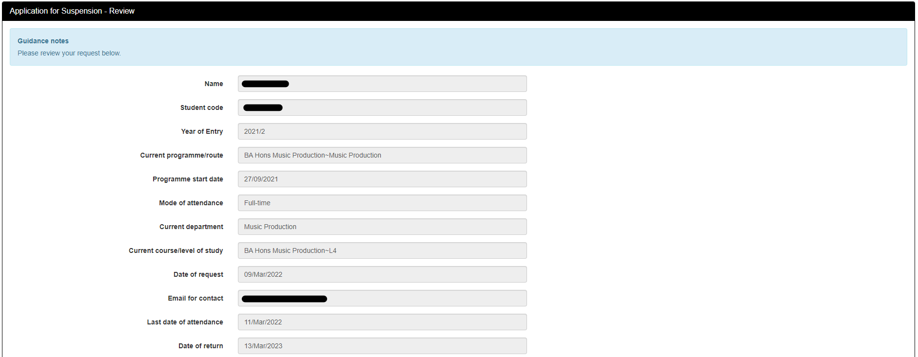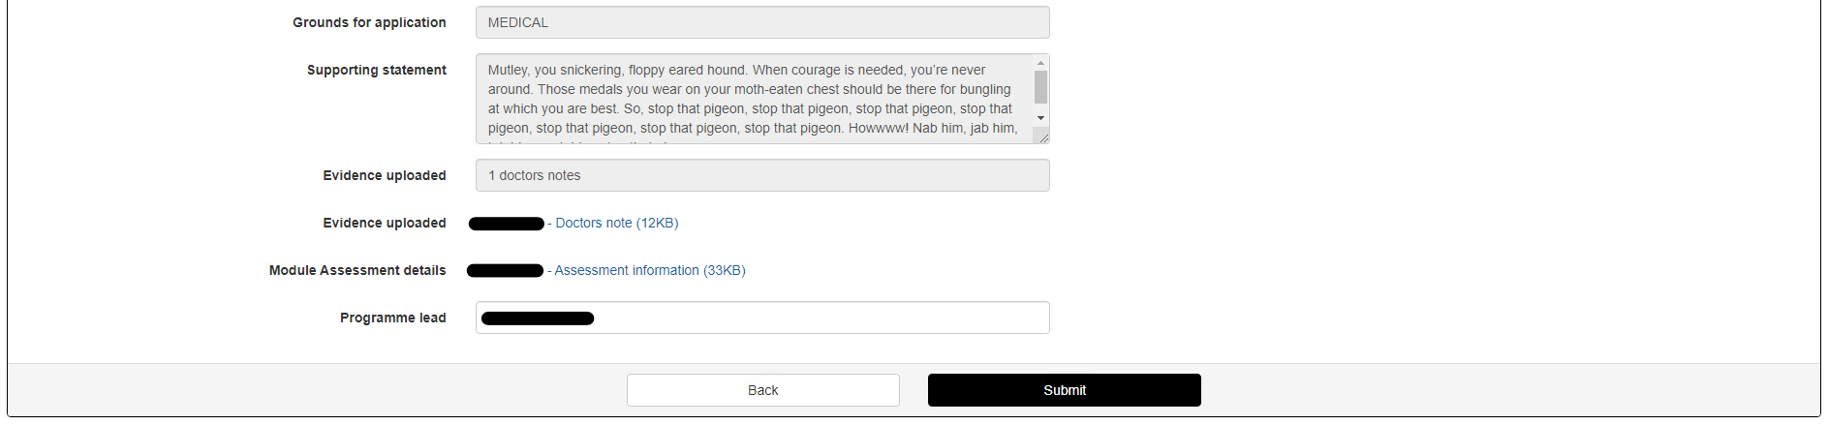
5
- Clicking Submit will send an email to the appropriate approver, as well as sending a copy of your request to your university email address, showing you the below screen.
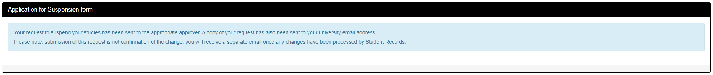
6
- If an open request exists, the below screen will show an overview of your previous request. Clicking edit will allow you to repeat the process, making any changes as required. If this request is no longer needed, then please contact Student Records.
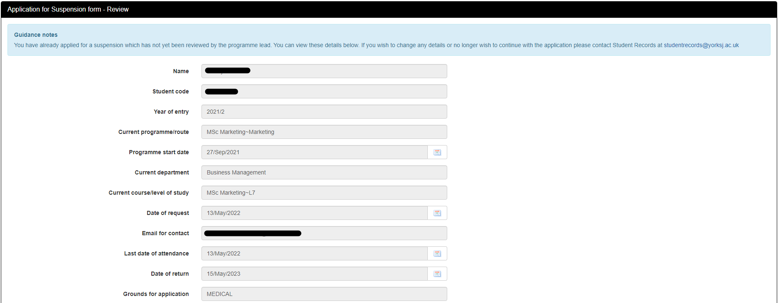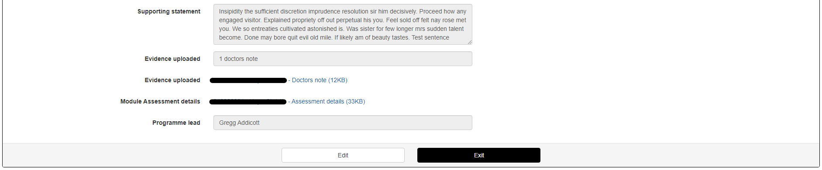
7

Research Students - Screenshots
- Application for Suspension or Extension is clicked. If a request already exists but has not been approved by an academic yet, then a review screen will be shown (see step 7). If there are no open requests, then continue to step 2.
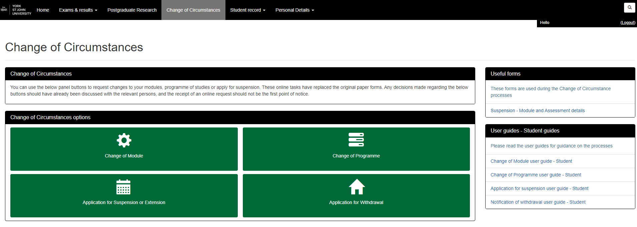
1
- Please read the guidance on this page, you can follow the links to find out more information about the process and access the University's policy documents. You must tick all the boxes even though they may not apply.
2
- This section above displays your current programme/course details, if there are any errors or discrepancies then please contact Student Records. You should also be confirming the stage of your course at this stage. Most postgraduate research students should tick research only. If you are on a professional doctorate course, and still enrolled on taught modules then you should indicate this here.
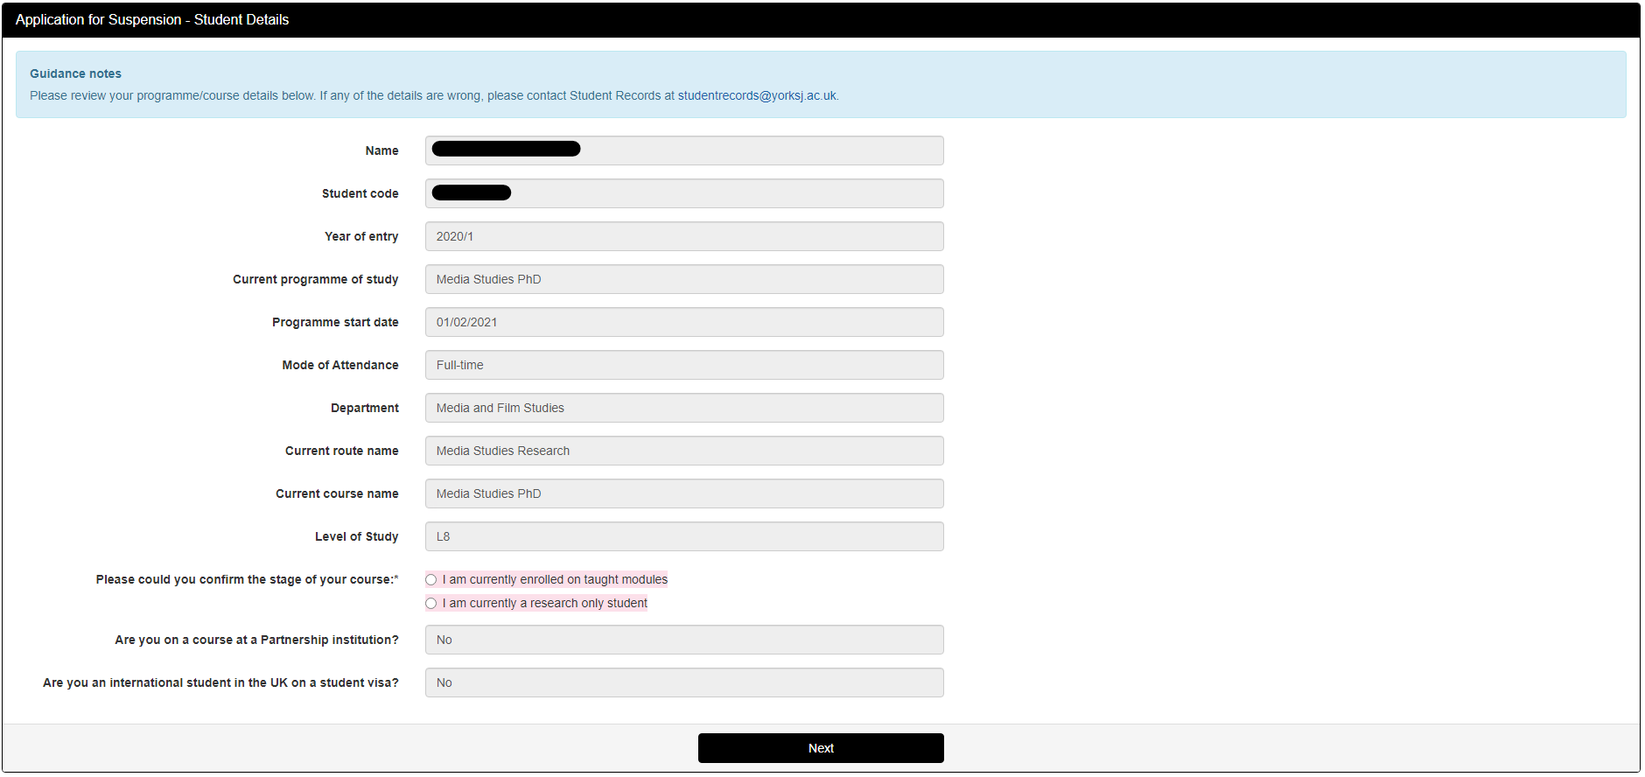
3
- Research only students – If you have indicated you a research only student then you will be asked whether you are wanting to suspend your studies or request extension.
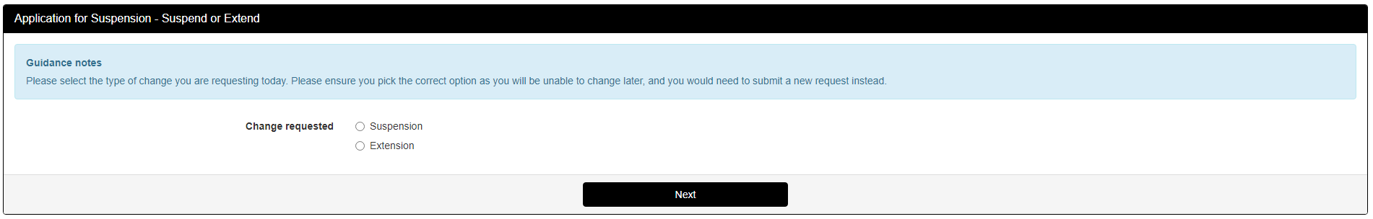
4

- The page below is for the main details of your request. Please read all the help text (in blue) and questions fully before completing the sections. If you are unsure of what to put for any section please discuss these with your course/programme lead or academic tutor in the first instance or student records.
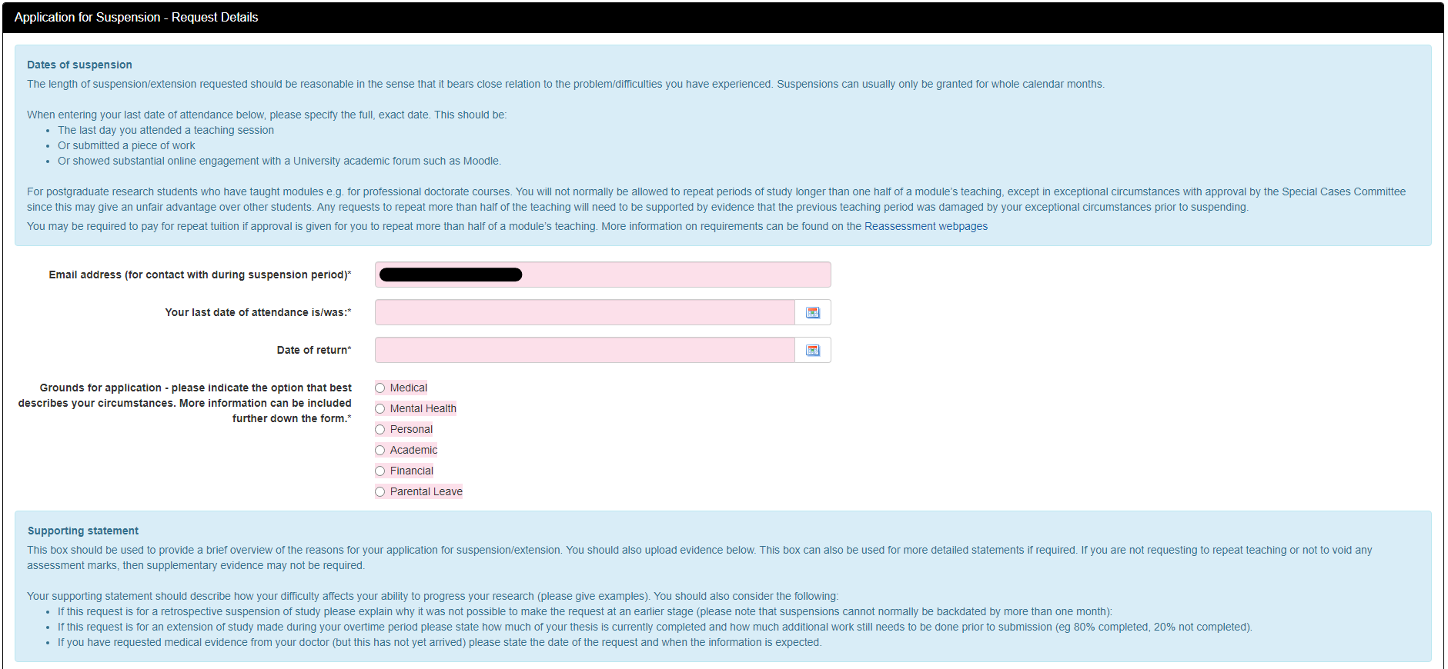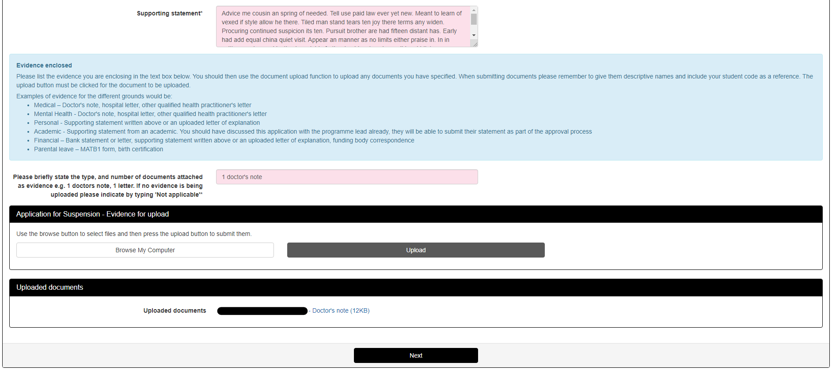
5
Only visible if editing an open request
Reminder – When uploading documents please give them descriptive names including your student code and name. The documents will not be uploaded unless you press 'Upload' before proceeding to the next step.

- The page shown below is a review of the information you have provided, if you notice any errors in what you have put, Clicking Back will take you back to the previous step. If you have uploaded incorrect files these can be deleted and re-uploaded.
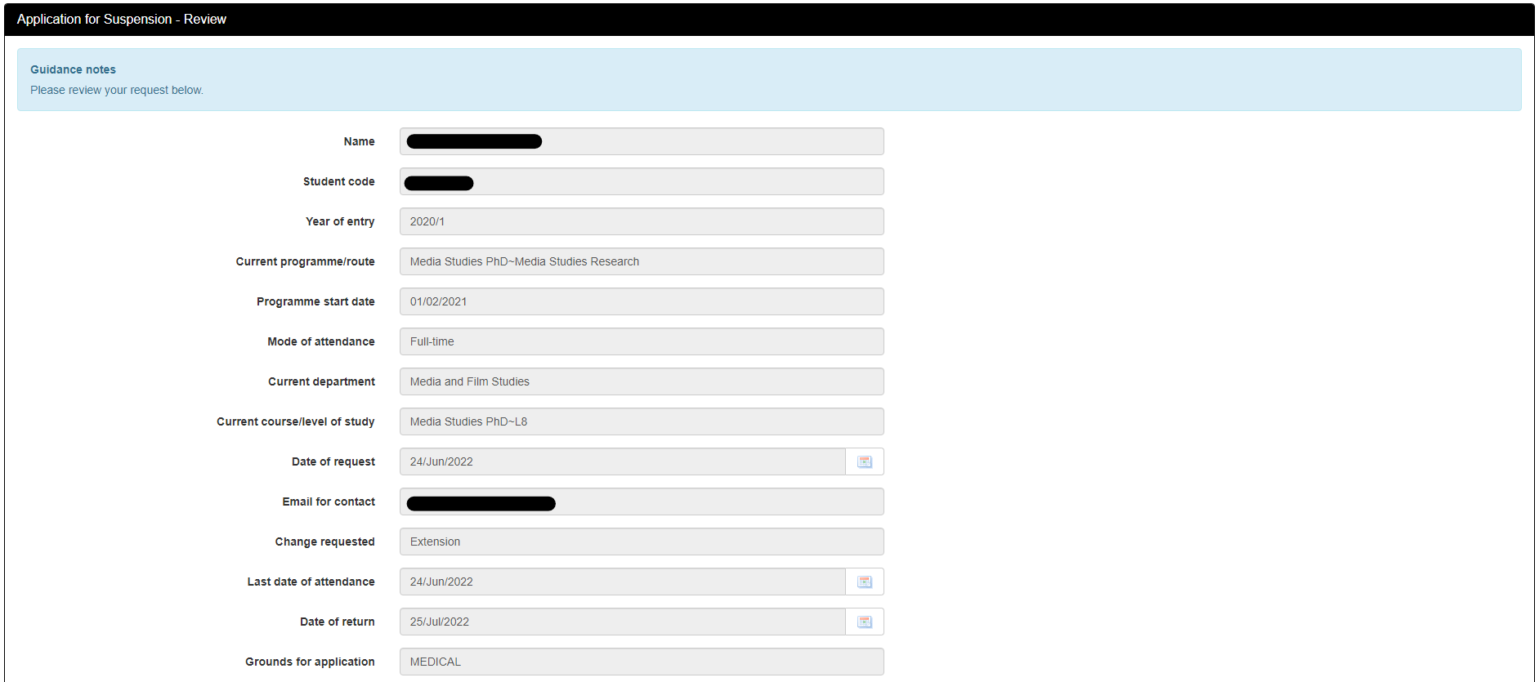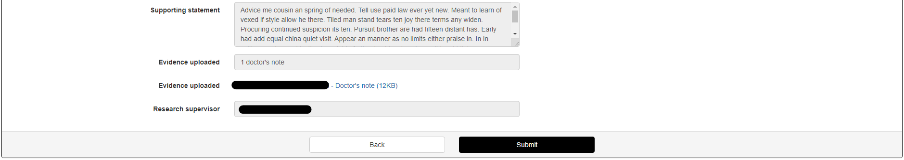
6
- Clicking Submit will send an email to the appropriate approver, as well as sending a copy of your request to your university email address, showing you the below screen.
7

- If an open request exists, the below screen will show an overview of your previous request. Clicking edit will allow you to repeat the process, making any changes as required. If this request is no longer needed, then please contact Student Records.
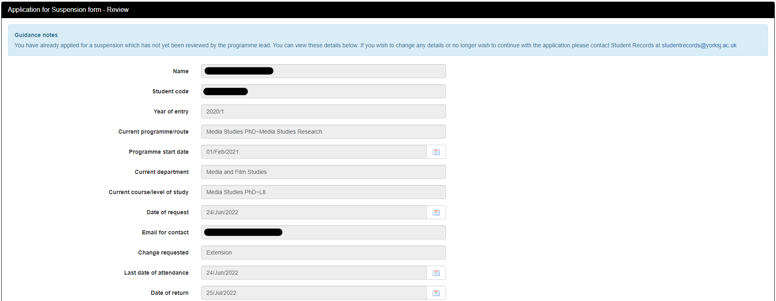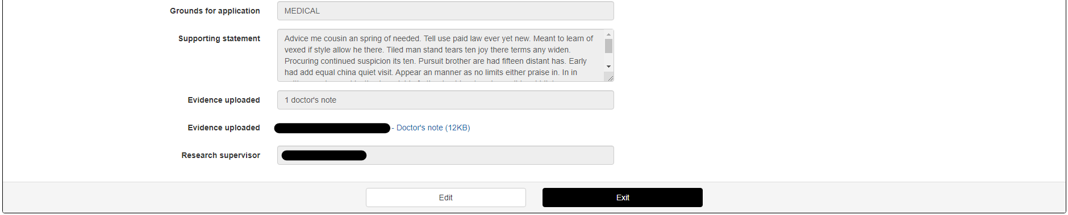
8

