Change of Programme
  - User guide – Change of Programme (Student)

Student task

Overview
This online process has replaced the previous paper forms for the Change of Programme process. It can be found on eVision under the Change of Circumstances tab alongside other changes to your programme of study.
The most important part of this process is discussing any changes with your course lead, academic tutor, or other university contact e.g. PASS or Student Records.

Screenshots
- Change of Programme is clicked. If a request already exists but has not been approved yet, then a review screen will be shown (see step 5). If there are no open requests, then it will continue to step 2.
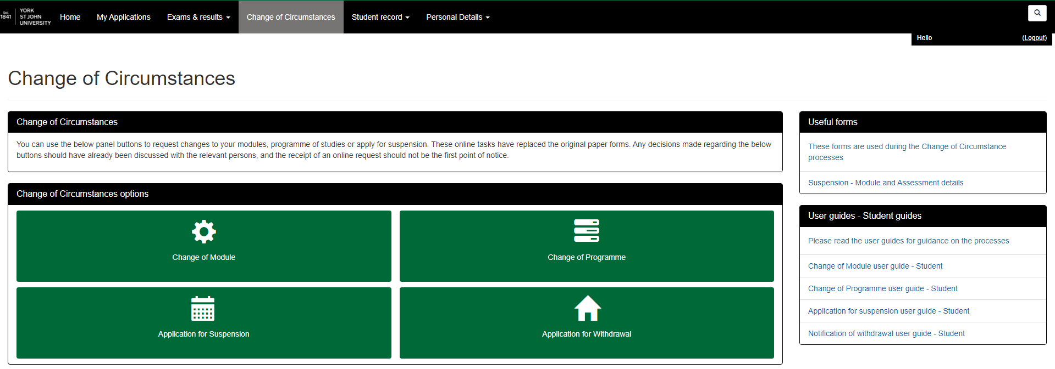
1
- Please read the guidance on this page. You must tick all of the boxes to continue, even if they do not apply.
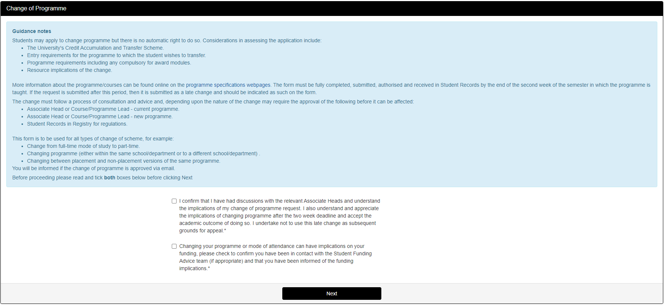
2
- The section below displays your current programme/course details, if there are any errors or discrepancies then please contact Student Records. Please read the guidance at the top of the page carefully. Clicking Next takes you to the next page.
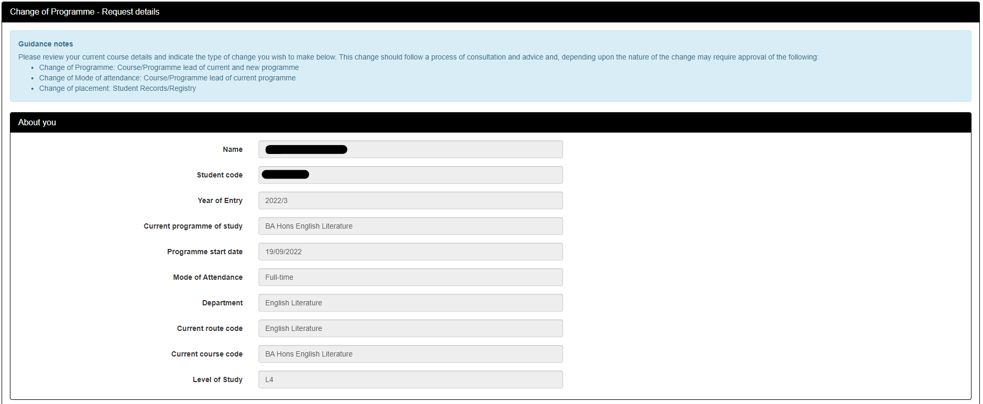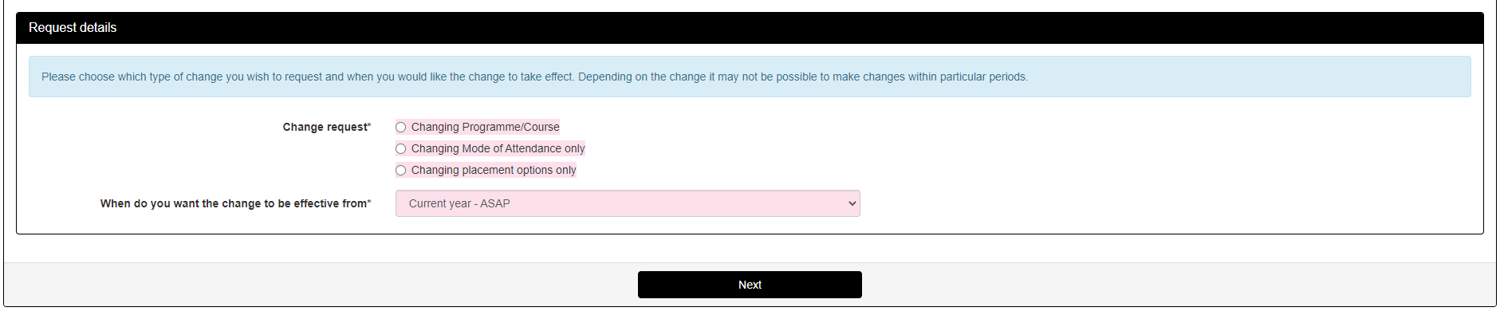
3

Change of programme
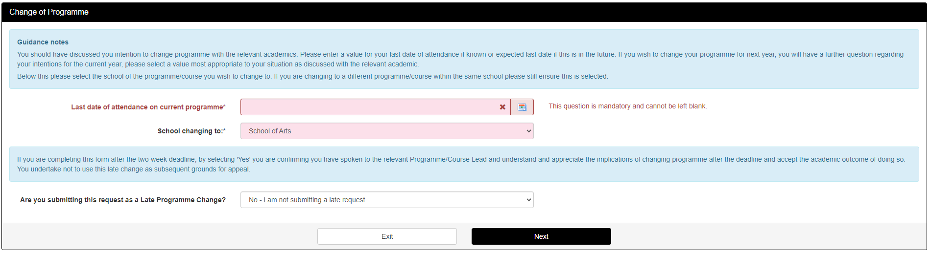
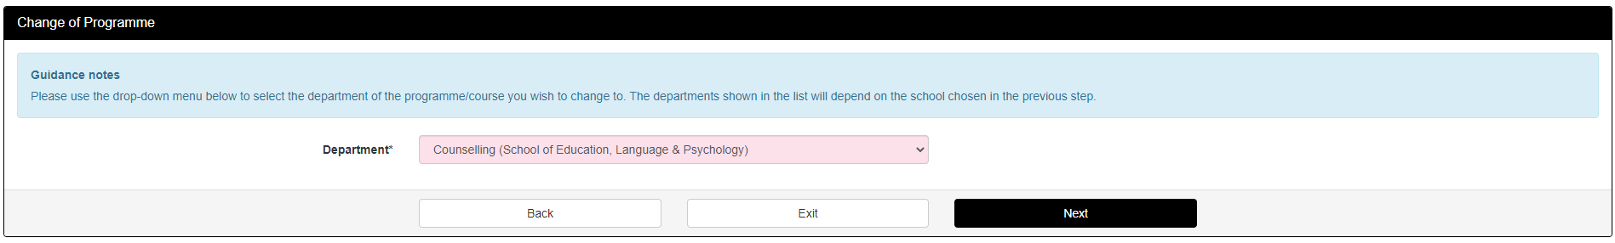
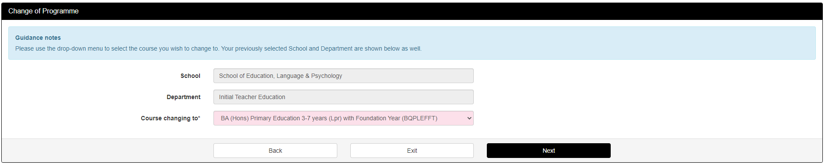
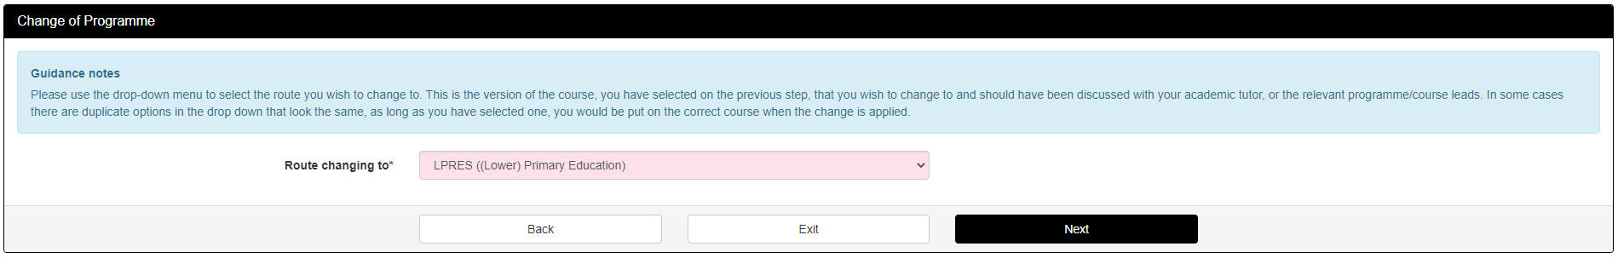
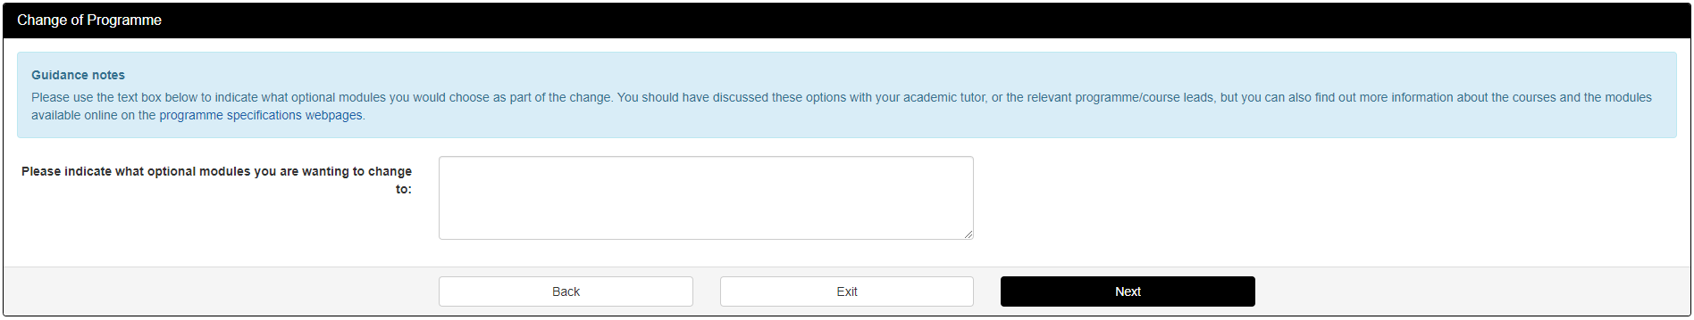
DBS required course
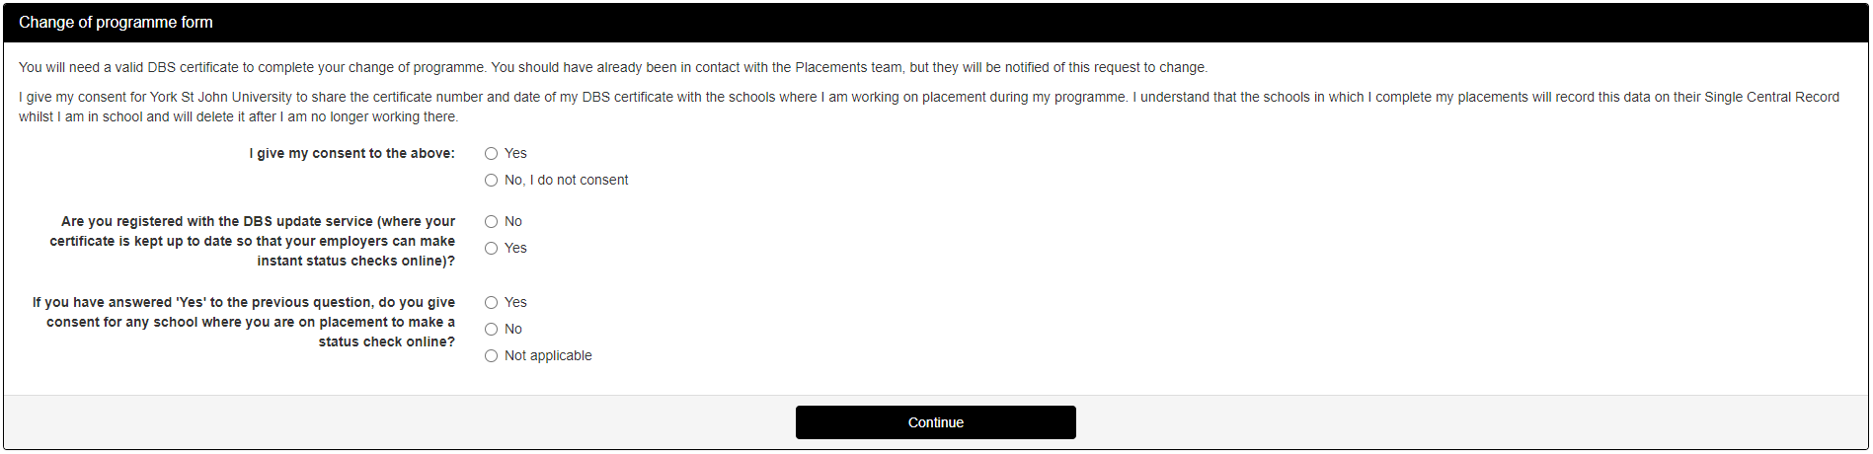
Primary Ed course
