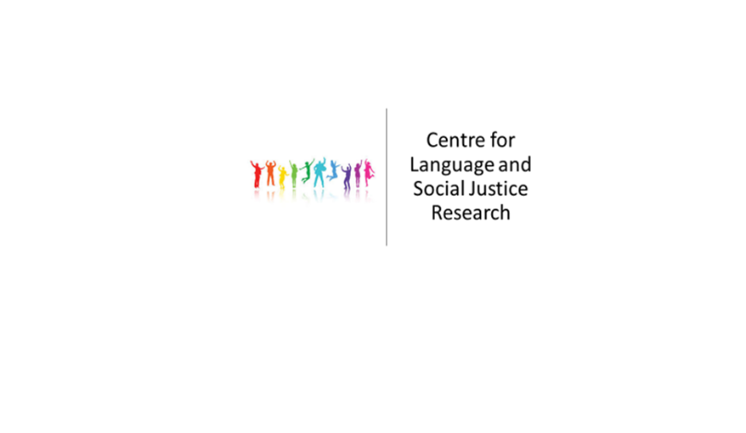

**Centre for Language and Social Justice Research**

**Seminar Series**

**Semester 2 2019-20**

12th February 2020 **Nick Rowe (Converge, YSJ)**

‘Students’ not ‘service users’, ‘discovery’ not ‘recovery’: Language and mental health

2.00-3.30pm, DG/126

26th February 2020 **Chisato Danjo & Chris Moreh (YSJ)**

Complementary schools in the global age: a multi-level critical analysis of *hoshuko* discourses and practices

2.00-3.30pm, DG/126

11th March 2020 **James Simpson (University of Leeds)**

Multilingualism and language education

2.00-3.30pm, DG/126

29th April 2020 **Khawla Badwan (Manchester Metropolitan University)**

Unmooring language for social justice: Young people talking about language in/and place in Manchester, UK

2.00-3.30pm, DG/126