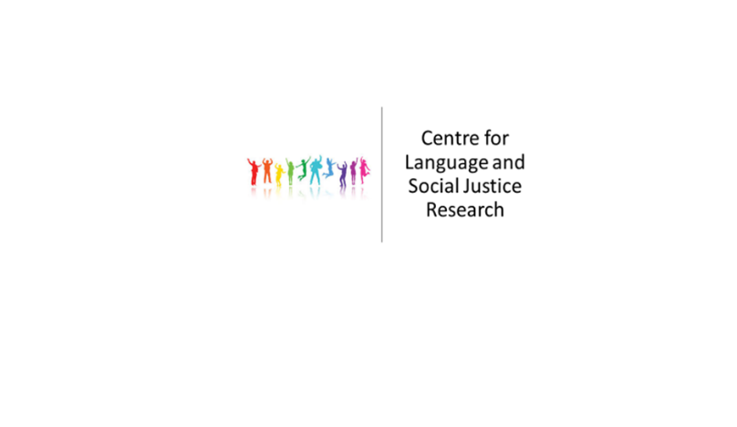

**Centre for Language and Social Justice Research**

**Seminar Series**

**Semester 1 2019-20**

9th October 2019 **Helen Sauntson**

                                       Teaching and researching language and social justice

2.00-3.30pm, DG/227

23rd October 2019 **Rachel Conlon**

‘I feel like I have a voice’: Collaborative, creating learning in a University-Prison partnership

2.00-3.30pm, DG/227

6th November 2019 **Liz Morrish**

The data and discourse of the TEF

2.00-3.30pm, DG/227

4th December 2019 **Gary Craig**

Is there such a thing as global social justice?

2.00-3.30pm, DG/227