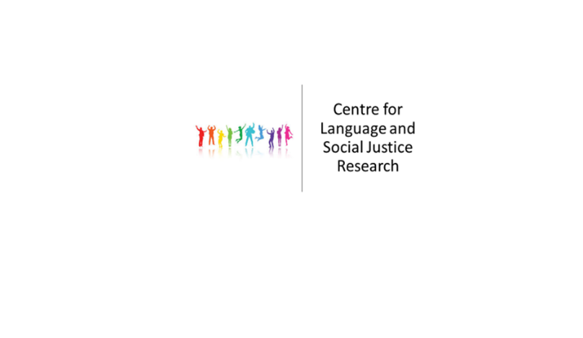

**Centre for Language and Social Justice Research**

**Seminar Series**

**Semester 1 2022-23**

12th October 2022 LSJ Planning and strategy meeting

2.00-3.30pm

Room: DG127

26th October 2022 Dr Daniel Edmondson (York St John University)

Unconscious reactions to colourful language: The impact of identity and linguistic reclamation on the cognitive processing of LGBTQ+ slurs

2.00-3.30pm

Room: DG127

23rd November 2022 Dr Indu Meddegama & Dr Maja Skender-Lizatovic

Community Language School – Sharing experiences

2.00-3.30pm

Room: DG127

7th December 2022 Prof Jo Angouri (University of Warwick)

2.00-3.30pm

Room: DG127