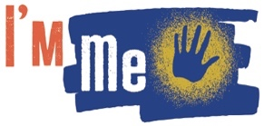 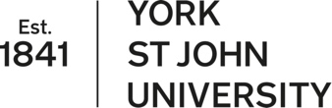 

**I’m Me Festival –**

**Inclusive Creative Methods Symposium: Thinking through Art**

Thursday 19 June 2025

The I’m Me Festival is the culmination of a two-year AHRC funded research project utilising creative methods to work with learning disability arts organisations to explore key themes of identity, representation and voice. The Festival will incorporate performances, films and artworks from our seven partner organisations: Mind the Gap, About Face, Confidance, Hijinx, Lung Ha, Open Theatre and Under the Stars.

Alongside the Festival we are inviting proposals for a symposium on the theme of **inclusive methods practice: thinking through art.**

Inclusive research, as proposed by Walmsley and Johnson (2003) is research where people with learning disabilities:

* Are involved in all stage of the research
* Are supported by non-learning disabled people
* Believe the research topic is important
* Have some control over the research
* Are able to understand the research

Creative or arts-based methods are often employed in inclusive research (Fox & Macpherson, 2015; Mannion, 2024; Reason, 2024). Creative methods understands all humans as inherently creative beings who can use art in the creation of new knowledge (Conrad & Beck, 2015). Both inclusive research and creative methods align themselves with concerns around social and epistemic justice and the project of building a better world. In practice, this kind of research is complex and raises numerous questions and opportunities for learning.

This symposium will be in-person with a single stream of presentations, each given space to breath and elaborate. This is in recognition of the complexity of the issues and in desire to enable presentations to take innovative and accessible approaches to presentation.

We invite applications for 20 minute presentations that engage with the practicalities and imperfections of working with creative methods in inclusive research. This could include, but is not limited to presentations engaged with:

* Ethics, both formal and informal
* Facilitation practices
* Knowledge translation, analysis, meaning making
* Authorship, dissemination, impact
* Building meaningful partner relationships
* Specific arts-based approaches

The symposium will take place noon to 4pm Thursday 19th June and attendees are invited to stay for workshops, film screenings and performances at the I’m Me Festival immediately afterwards (preliminary timing 4-8pm).

The symposium and festival attendance will be free. [I’m Me](https://www.yorksj.ac.uk/research/institute-for-social-justice/research-themes/neurodiversity-and-learning-disabilities/im-me/) is part of the Institute for Social Justice at York St John University and will take place in York, UK.

[To submit a presentation please fill out this form by 30 November.](https://forms.gle/4VGmgaKM2wRNkvVK9) We will respond to all submissions by 14 December.