Quadratic Equations

Study Development Factsheet

A quadratic equation is a polynomial of the form

$$f\left(x\right)=ax^{2}+bx+c$$

where $a,b,c$ are constants and $a≠0$.

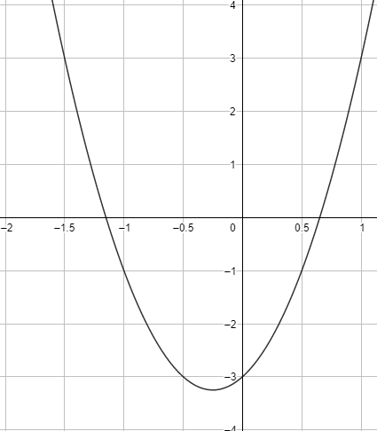If we were to draw this, it makes a shape called a parabola:

This is shaped like a ∪ or a ∩, and its position and depth is determined by $a,b$ and $c$.

Quadratic equations are used in many different ways and fields. For example, economists use them for calculating revenue, you can use them to calculate the area of an oddly shaped room, they are also used often in chemistry and physics.

$c$ gives the point at which the parabola crosses the y-axis, and the solutions to $f\left(x\right)=0$ give us the points at which the parabola crosses the x-axis.

Quadratic Equations

Study Development Factsheet

## Solving quadratic equations

In order to solve (find $x$ such that $f\left(x\right)=0$) a quadratic equation, we can use one of several methods:

### Factorising by inspection

This is where we put the equation in the form $\left(px+q\right)\left(rx+s\right)=0$, such that $pq=a$, $ps + qr =b$, and $qs=c$. Sometimes this is quite easy to figure out, especially when $a=1.$ In this case, we tend to ask the question ‘what two numbers add to give $b$ and multiply to give $c$? The solutions to the quadratic equation are then given by $x=\frac{-q}{p}$ and $x=\frac{-s}{r}.$

For example, for the quadratic equation $x^{2}+3x+2=0$, we see that the only integer factor pairs of $c=2$ are 2 and 1 or -2 and -1. We can see that since 2+1=3, these must be $q$ and $s,$ so $x^{2}+3x+2=\left(x+2\right)\left(x+1\right)=0$. Therefore, the solutions to this equation are $x=-2,$ and $x=-1.$

If we try to solve something like $x^{2}+2x-7=0$ by simply looking at it and hunting out the factors, we run into some problems. This is where we use one of our other methods for solving.

Quadratic Equations

Study Development Factsheet

### The quadratic formula

This is a foolproof method for solving. If you are ever struggling to factorise a quadratic, this should be your go-to method.

We find values for $x$ when $ax^{2}+bx+c=0$ by evaluating:

$$x=\frac{-b±\sqrt{b^{2}-4ac}}{2a}$$

**Note: $±$**  in this case means ‘do the calculation once with a + where the $±$ is, and then once with a – where the $±$ is’

For example, if we try to solve $x^{2}+2x-7=0,$ we have

$$x=\frac{-2±\sqrt{2^{2}-4×1×\left(-7\right)}}{2×1}$$

$$=\frac{-2±\sqrt{32}}{2}$$

$$=-1±2\sqrt{2}$$

Using a calculator, we find solutions of (approximately) $x=-3.828$ and $x=1.828$.

Quadratic Equations

Study Development Factsheet

### Completing the square

We complete the square on $ax^{2}+bx+c=0$ by carrying out the following steps:

* Divide by $a$ to get: $x^{2}+\frac{b}{a}x+\frac{c}{a}=0$
* Take $\frac{c}{a}$ away from both sides to get: $x^{2}+\frac{b}{a}x=-\frac{c}{a}$
* Rewrite the left-hand side in the format: ${\left(x+\frac{b}{2a}\right)}^{2}-\frac{b^{2}}{4a^{2}}$
* Add $\frac{b^{2}}{4a^{2}}$ to both sides to get: ${\left(x+\frac{b}{2a}\right)}^{2}=\frac{b^{2}}{4a^{2}}-\frac{c}{a}$
* Take the square root of both sides: $x+\frac{b}{2a}=±\sqrt{\frac{b^{2}}{4a^{2}}-\frac{c}{a}}$
* Take $\frac{b}{2a}$ away from both sides to give a final answer of: $x=-\frac{b}{2a}±\sqrt{\frac{b^{2}}{4a^{2}}-\frac{c}{a}}$

This method can be a bit complicated or difficult to remember. If it makes sense to you, then use it, as it works for all quadratic formulae, however we generally recommend that you use the quadratic formula instead as it’s a bit quicker.

For example, if we try to solve $2x^{2}+22x+7=0$ by completing the square, we have:

* Divide by 2, to get: $x^{2}+11x+\frac{7}{2}=0$
* Take $\frac{7}{2}$ away from both sides, to get: $x^{2}+11x=-\frac{7}{2}$
* Rewrite the left-hand side in the format: ${\left(x+\frac{11}{2}\right)}^{2}-\frac{121}{4}$
* Add $\frac{121}{4}$ to both sides to get: ${\left(x+\frac{11}{2}\right)}^{2}=\frac{57}{2}$
* Take the square root of both sides: $x+\frac{11}{2}=±\sqrt{\frac{57}{2}}$
* Take $\frac{11}{2}$ away from both sides to get a final answer of: $x=-\frac{11}{2}±\sqrt{\frac{57}{2}}$

So, $x=-10.672$ and $x=0.328$.

Quadratic Equations

Study Development Factsheet

## Different kinds of roots

We sometimes refer to the solutions as ‘roots’ of the equation. There are three different kinds of roots to a quadratic equation: distinct roots, repeated roots, and complex roots. We determine which kind they are by finding something called the ‘discriminant’, given by $d=b^{2}-4ac$.

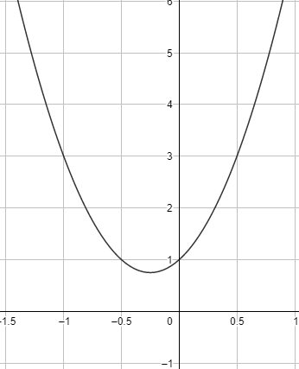If $d<0$, we have complex roots. This means that the roots do not exist in the real plane, and the parabola will look something like this:

The graph of $f\left(x\right)=4x^{2}+2x+1$.

Quadratic Equations

Study Development Factsheet

Alternatively, the parabola might look something like:

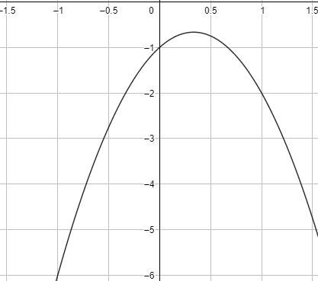

The graph of $f\left(x\right)=-3x^{2}+2x-1$.

If $d=0$, we have a repeated root. This is where the parabola touches the x-axis rather than crossing it, so only one root exists. This may look something like:

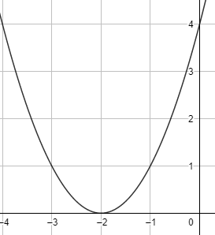The graph of $f\left(x\right)=x^{2}+4x+4$.

Quadratic Equations

Study Development Factsheet

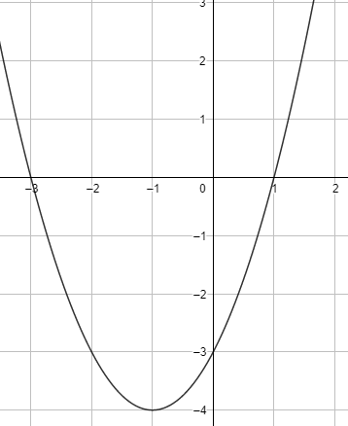If $d>0$, we have two distinct roots. This may look something like:

The graph of $f\left(x\right)=x^{2}+2x-3$.

You may have spotted that the discriminant is part of the quadratic formula:

$$x=\frac{-b±\sqrt{b^{2}-4ac}}{2a}$$

This is why the solutions are affected by the value of the discrimant, as when $d<0$, $\sqrt{d}$ is imaginary (or does not exist in the real plane), so we have complex roots. When $d=0$, we have $d=\frac{-b±\sqrt{0}}{2a}=\frac{-b}{2a}$, so there is only one root. When $d>0$, $\sqrt{d}$ is a real value, so we have two solutions.

**Support**: Study Development offers workshops, short courses, 1 to 1 and small group tutorials.

* Join a tutorial or workshop on the [Study Development tutorial and workshop webpage](https://www.yorksj.ac.uk/students/study-skills/study-development-tutorials/) or search ‘YSJ study development tutorials.’
* Access our Study Success resources on the [Study Success webpage](https://www.yorksj.ac.uk/students/study-skills/study-success/) or search ‘YSJ study success.’