Complex numbers

Study Development Worksheet

What are complex numbers?

We can find the square root of any positive number. For example, $\sqrt{4}=±2$. If we attempt to find the square root of a negative number on a calculator, it will return an error. This is where we introduce ‘imaginary numbers’- numbers that are multiplied by $\sqrt{-1}$. We write $\sqrt{-1}=i$. For example, $\sqrt{-4}=\sqrt{4}×\sqrt{-1}= ±2 ×i =±2i$.

A complex number is a number that has both a real and an imaginary part, for example $4 + i$ is a complex number because it has a real part, 4, and an imaginary part $i$.

Argand diagrams

We can draw a complex number on a set of axes called an Argand diagram. Instead of the typical x and y axes, we have a real axis and an imaginary axis. For a complex number of the form $a+bi$, we use $a$ as the coordinate on the real axis, and $b$ as the coordinate on the imaginary axis.

For example, we plot $A=3 + 2i$ on this Argand diagram:

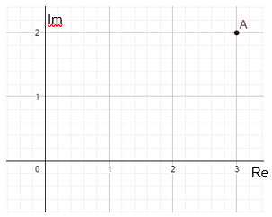

Later, we will look into the modulus and argument of complex numbers and how these fit onto an Argand diagram.

Complex numbers

Study Development Worksheet

## Complex number arithmetic

There are several rules for manipulating complex numbers.

Addition:

$$\left(a+bi\right)+\left(c+di\right)=\left(a+c\right)+\left(b+d\right)i$$

Subtraction:

$$\left(a+bi\right)-\left(c+di\right)=\left(a+c\right)+\left(b-d\right)i$$

Multiplication:

$$\left(a+bi\right)×\left(c+di\right)=ac-bd+\left(ad+bc\right)i$$

Division:

$$\frac{a+bi}{c+di}=\frac{-ac-bd}{-c^{2}-d^{2}}+\frac{\left(ad-bc\right)i}{-c^{2}-d^{2}}$$

The rules for multiplication and division may not immediately make sense. Let’s look at how we got them.

Multiplication: $\left(a+bi\right)\left(c+di\right)$

If you have studied quadratic equations before, this format may look quite familiar to you. We multiply the brackets using the FOIL method. This means that we multiply the

First two numbers: $a ×c$, then multiply the

Outside two numbers: $a ×di,$ then multiply the

Inside two numbers: $c ×bi,$ then multiply the

Last two numbers: $bi ×di.$

We then add all of these together, to get $\left(a+bi\right)\left(c+di\right)=ac+adi+bci+bdi^{2}$.

We must now consider $i^{2}$. Since $i=\sqrt{-1},$ when we square it we get $i^{2}={\left(\sqrt{-1}\right)}^{2}=-1$, therefore $bdi^{2}=bd\left(-1\right)=-bd$.

So, we have $\left(a+bi\right)\left(c+di\right)=ac+adi+bci-bd.$

We then tidy this up: $\left(a+bi\right)\left(c+di\right)=ac-bd+\left(ad+bc\right)i.$

Complex numbers

Study Development Worksheet

Division: $\frac{a+bi}{c+di}$

This process for dividing complex numbers is also called ‘making the denominator real’, and will often be referred to as ‘putting the fraction into Cartesian form’.

The method for this may seem unusual. Our goal is for the denominator to be real (ie, not complex) so that any further arithmetic we do with the complex number is easier. We do this by multiplying the fraction by another fraction.

Since $i^{2}=-1$, $i^{2}$ is not imaginary, so we multiply the denominator by a complex number that gets rid of the $i$’s and creates only real numbers.

For a denominator $c+di$, we need to use the denominator $-c +di$ on our multiplying fraction. We set the numerator of the multiplying fraction to be equal to the denominator, so that we do not change the value of the original fraction, since $\frac{-c+di}{-c+di}$ = 1 and anything multiplied by 1 is itself.

The calculation looks like this:

$\frac{a+bi}{c+di}$ $×$ $\frac{-c+di}{-c+di}$ = $\frac{\left(a+bi\right)\left(-c+di\right)}{\left(c+di\right)\left(-c+di\right)}$ = $\frac{-ac+adi-bci+bdi^{2}}{-c^{2}+cdi-cdi+d^{2}i^{2}}$

= $\frac{-ac+\left(ad-bc\right)i+bd\left(-1\right)}{-c^{2}+d^{2}\left(-1\right)}$ = $\frac{-ac-bd+\left(ad-bc\right)i}{-c^{2}-d^{2}}$

Since $c$ and $d$ are real numbers, the denominator is now real. If we wanted to then put the complex number into the form $x+iy$ with $x$ and $y$ real, we separate the fraction into the real part and the imaginary part:

$\frac{a+bi}{c+di}$ = $\frac{-ac-bd}{-c^{2}-d^{2}}$ + $\frac{\left(ad-bc\right)i}{-c^{2}-d^{2}}$

Complex numbers

Study Development Worksheet

## Polar form

Sometimes it is beneficial to us to have a complex number in polar form. If we look at a value on an Argand diagram:

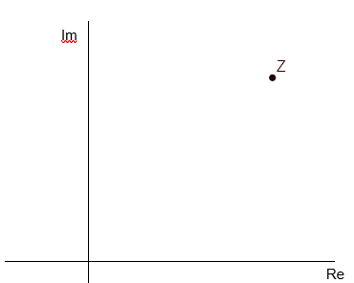

We can draw a line from this value to the origin:

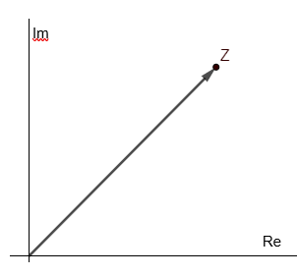

Complex numbers

Study Development Worksheet

This now allows us to find out certain information about the point z. We can calculate the length of the line, and the angle between the point z and the real axis. We call these values the modulus and argument of $z=x+yi$.

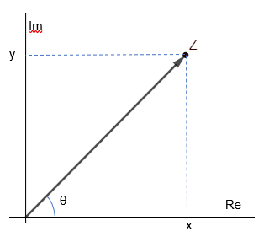

## Modulus

The ‘modulus’, $r$, is the length of the line between $z$ and the origin. We calculate this using Pythagoras’s Theorem: ${\left(\left|z\right|\right)}^{2}=x^{2}+y^{2}$, so therefore $\left|z\right|=r =\sqrt{x^{2}+y^{2}}.$

## Argument and quadrant adjustments

The ‘argument’ $\arg\left(z\right)$ is the angle $θ$ between z and the real axis. We calculate this using the tangent function: $\tan\left(α\right)=\frac{y}{x}$, and so $α=\tan^{-1}\left(\frac{y}{x}\right).$ We then adjust $α$ based on the quadrant that $z$ is in to find the argument $θ.$

|  |  |  |
| --- | --- | --- |
| **Quadrant** | **x and y values** | $θ$**from $α$** |
| 1st | x > 0, y > 0 | $$θ=α$$ |
| 2nd | x < 0, y > 0 | $$θ= π- α$$ |
| 3rd | x < 0, y < 0 | $$θ= α- π$$ |
| 4th | x > 0, y < 0 | $$θ= - α$$ |

Complex numbers

Study Development Worksheet

We can see why in the following diagrams:

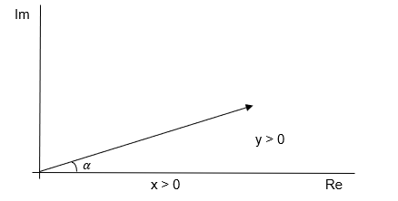

In the first quadrant, the angle between $z$ and the real axis is equal to $\tan^{-1}\left(\frac{y}{x}\right)= α$, so we do not adjust this angle.

For the second quadrant:

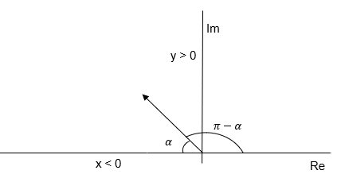

$\tan^{-1}\left(\frac{y}{x}\right)= α$ is not the angle between $z$ and the real axis. The entire angle of the first and second quadrants is $π$, so we simply take the angle $α$ away from $π$.

Complex numbers

Study Development Worksheet

For the third quadrant:

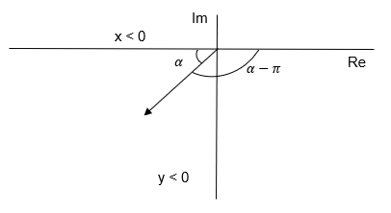

The entire angle of the 3rd and 4th quadrants is $-π$. Since we are removing $α$ from $-π$, we must add the $α$ to $-π$ (as opposed to minusing it, since we are in the negative quadrants).

Finally, for the fourth quadrant:

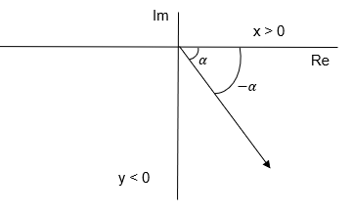

We find the negative of $α$ since we are in the negative quadrants.

Complex numbers

Study Development Worksheet

## Modulus and argument example

For example, if we were to calculate the modulus and argument of $w=3+3i$:

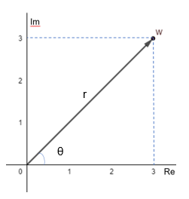

We find the modulus using the formula above: $\left|w\right|=r=\sqrt{x^{2}+y^{2}}=\sqrt{3^{2}+3^{2}}=\sqrt{18}=3\sqrt{2}.$

We find the argument: $\arg\left(w\right)=θ=\tan^{-1}\left(\frac{y}{x}\right)=\tan^{-1}\left(\frac{3}{3}\right)=\frac{π}{4}.$ Remember that we always work in radians when drawing Argand diagrams.

We can also find expressions for $x$ and $y$ in terms of $r$ and $θ$. Since $y$ is the length of the angle $θ$, we use the sine function to find it: $\sin\left(θ\right)=\frac{y}{r}$, and so $y=r\sin\left(θ\right).$

Similarly, $x$ is the side length adjacent to the angle $θ$, so we use the cosine function to find it: $\cos\left(θ\right)=\frac{x}{r}$, and so $x=r\cos\left(θ\right)$.

With these new expressions, we can write $z=x+iy$ in terms of $θ$ and $r$:

$$z=x+yi=r\cos\left(θ\right)+r\sin\left(θ\right)i$$

Which we can tidy up to get: $z=r\left(\cos\left(θ\right)+i\sin\left(θ\right)\right)$. When $z$ is in this format, we say it is in polar form.

From our earlier example, we can write $w$ in polar form: $w=3+3i=3\sqrt{2}\left(\cos\left(\frac{π}{4}\right)+i\sin\left(\frac{π}{4}\right)\right).$

Complex numbers

Study Development Worksheet

To take this a step further, we use the property that the sine and cosine functions have. We have that $\sin\left(θ\right)=\frac{1}{2i}\left(e^{iθ}-e^{-iθ}\right)$ and $\cos\left(θ\right)=\frac{1}{2}\left(e^{iθ}+e^{-iθ}\right)$. If you are unsure of where this comes from, look at the Taylor expansions of sine, cosine and e.If you are unsure of where this comes from, look at the Taylor expansions of sine, cosine, and e.

If we replace $sin\left(θ\right)$ and $\cos\left(θ\right)$ with these exponential forms, we get:

$$z=r\left(\cos\left(θ\right)+i\sin\left(θ\right)\right)=r\left(\frac{1}{2}\left(e^{iθ}+e^{-iθ}\right)+i\frac{1}{2i}\left(e^{iθ}-e^{-iθ}\right)\right)$$

This expanded gives:

$$z=r\left(\frac{e^{iθ}}{2}+\frac{e^{iθ}}{2}+\frac{e^{-iθ}}{2}-\frac{e^{-iθ}}{2}\right)=re^{iθ}$$

Therefore, we can write $z$ in three formats:

$$z=x+yi$$

$$z=r\left(\cos\left(θ\right)+i\sin\left(θ\right)\right)$$

$$z=re^{iθ}$$

These each have times when they are the most useful format. We generally use $z=x+yi$, and we call this ‘Cartesian form’, however if we are asked a question such as ${\left(x+yi\right)}^{20}$, this would take a very long time to calculate. If we put the equation into the form ${\left(re^{iθ}\right)}^{20}$, we can calculate this much faster, as this becomes $re^{20iθ}$.

Complex numbers

Study Development Worksheet

## Converting from polar form to Cartesian

If we are given a complex number in the form $z=r\left(\cos\left(θ\right)+i\sin\left(θ\right)\right)$ or $z=re^{iθ}$ and we want to put it into the form $z=x+yi$ we can follow these steps:

1. Calculate $x=r\cos\left(θ\right)$.
2. Calculate $y=r\sin\left(θ\right).$
3. Write the number in the form $z=x+yi.$

For example, to convert $z=2\sqrt{2}e^{\frac{3πi}{4}}$ into the form $z=x+yi,$ we calculate the following:

$x=2\sqrt{2}\cos\left(\frac{3π}{4}\right)=2\sqrt{2}\frac{-\sqrt{2}}{2}=-2.$

$y=2\sqrt{2}\sin\left(\frac{3π}{4}\right)=2\sqrt{2}\frac{\sqrt{2}}{2}=2.$

1. Therefore, $z=-2+2i.$

## Converting from Cartesian to polar form

If we are given a complex number of the form $z=x+yi,$ and we would like it in the form $z=r\left(\cos\left(θ\right)+i\sin\left(θ\right)\right)$ or $z=re^{iθ}$, we do the following:

1. Calculate $r=\sqrt{x^{2}+y^{2}}.$
2. Calculate $α=\tan^{-1}\left(\frac{y}{x}\right).$
3. Adjust $α$ based on the quadrant of $z$ to get $θ.$
4. Write the number in the form $z=r\left(\cos\left(θ\right)+i\sin\left(θ\right)\right)$ or $z=re^{iθ}.$

For example, to convert $z=-\sqrt{3}-i$ into polar form we calculate the following:

$r=\sqrt{{\left(-\sqrt{3}\right)}^{2}+{\left(-1\right)}^{2}}=\sqrt{4}=2.$

1. $α=\tan^{-1}\left(\frac{-1}{-\sqrt{3}}\right)=\frac{π}{6}$.
2. Since $x<0$ and $y<0$, $z$ is in the third quadrant and so we calculate $\frac{π}{6}-π=\frac{-5π}{6}=θ.$
3. Therefore, $z=2\left(\cos\left(\frac{-5π}{6}\right)+i\sin\left(\frac{-5π}{6}\right)\right)$ and $z=2e^{\frac{-5πi}{6}}.$

Complex numbers

Study Development Worksheet

**Support**: Study Development offers workshops, short courses, 1 to 1 and small group tutorials.

* Join a tutorial or workshop on the [Study Development tutorial and workshop webpage](https://www.yorksj.ac.uk/students/study-skills/study-development-tutorials/) or search ‘YSJ study development tutorials.’
* Access our Study Success resources on the [Study Success webpage](https://www.yorksj.ac.uk/students/study-skills/study-success/) or search ‘YSJ study success.’