Area

Study Development Factsheet

For various exams, you will be expected to memorise some formulas for area. You can look up your exam’s curriculum to find out which ones. In this factsheet, we discuss using the formulas for finding the area of a circle, a rectangle, and a triangle, as well as variants of these such as semicircles and squares.

## Rectangles

Area of a rectangle = width $×$ height

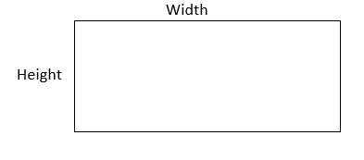

This is also true for a square (since squares are a type of rectangle), with the only difference being that height and width are the same length in that case.

For other types of quadrilaterals (e.g. a parallelogram or trapezium) there will either be a formula provided to you, or you will be able to divide the shape up into smaller parts that you are already familiar with (more on this in the Composite Area and the Using a Formula sections).

#### Example

What is the area of the floor of a rectangular room that is 3m by 6m?

#### Answer

3m 6m = 18m2.

This question could be phrased as “how much carpet would be required to cover the floor of the room?” in which case the answer would be the same, 18m2 of carpet.

## Triangles

Area of a triangle = (base $×$ height) $÷$ 2

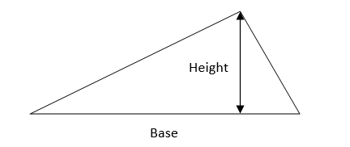

The base length is the length between any two corners, and the height is the length from the base to the third remaining corner. This is true of any triangle (equilateral, right-angled, scalene etc.), and any of the sides may be selected as the base.

The formula for a triangle’s area can be remembered more easily as it is the same as the rectangle formula, except that it is then halved, since a triangle is half as large as a rectangle with the same base and height. This is easiest to see with a right-angled triangle:

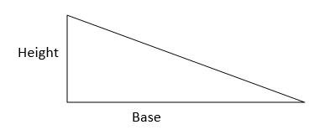

If we draw a rectangle with the same base and height as this triangle:

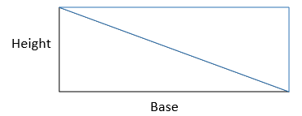

The area of this rectangle is “base $×$ height”, and to get the triangle back we would cut the shape in half along the diagonal, so the area of the triangle is “(base $×$ height) $÷$ 2”.

#### Example

Find the area of a triangle with base length 4cm and height 8cm.

#### Answer

Using the formula (base $×$ height) $÷$ 2:

(base $×$ height) $÷$ 2 = (4cm $×$ 8cm) 2 = 32cm2 2 = 16cm2

## Circles

Area of a circle = $π×{\text{r}}^{2}$

“r” is the radius of the circle (i.e. the length from the centre of the circle to the outside of the circle).

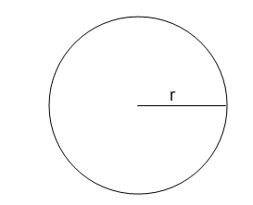

$π$ is the symbol for *pi* (pronounced pie). It is the ratio of the circumference of a circle compared with the diameter (meaning that the outside of the circle is always $π$ times bigger than the diameter). We use $π$ to find the area of a circle, the length of the diameter, and the length of the circumference.

$π$ is an *irrational* number*,* meaning that it has no exact place on a number line and the decimal part goes on forever (i.e. $π$ = 3.141592…), so we tend to round it up to 3.14 (don’t worry too much about this- you don’t need to know what an irrational number is for an equivalency exam).   
On some papers, you will be told what number $π$ should be taken as (it’s usually 3.14 but might be 3.1 or 3 on a non-calculator paper). This will either be written in the instructions on the front of the paper, or in a question where you need to use $π$.   
You may have a $π$ button on your calculator, which is a much more accurate choice, but since not everyone has that button, the answer that the examiner is looking for will be found using whatever they’ve asked you to take $π$ as.

${\text{r}}^{2}$ means r $×$ r. You could also write the formula as $π×\text{r}×\text{r}$ if you find that easier.

#### Example

Find the area of a circle with a 2m radius. Take $π$ as 3.14.

#### Answer

Using the formula :

= 3.14 (2m)2 = 3.14 2m 2m = 12.56m2

### Partial circles

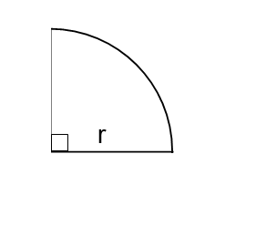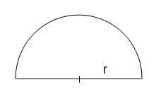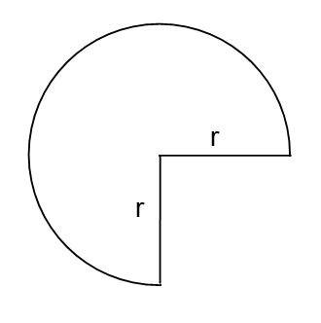A question may show only part of a circle and ask for the area of that. In this case, find the area as if it were a whole circle, and then take a fraction of that.

In these examples, the full circle would be $π×{\text{r}}^{2}$, and then we’d find $\frac{3}{4}×π×{\text{r}}^{2}$ for the first one, $\frac{1}{2}×π×{\text{r}}^{2}$ for the semicircle, and $\frac{1}{4}×π×{\text{r}}^{2}$ for the quarter of a circle.

#### Example

Find the area of a semicircle with base length 10cm. Take $π$ as 3.14.

#### Answer

If the base length is 10cm, then the radius length is half of that, so 5cm.

If the semicircle was a whole circle, the area would be:

= (5cm)2 = 3.14 25cm2 = 78.5cm2

## Composite area

Sometimes, you’ll need to find the area of a shape that isn’t as straightforward. In this case, there may be a formula provided for you to find the area, or you can split up the shape into parts of circles, triangles, and rectangles.

For example, if you need to find the area of the side of a house, you can split it into a triangle and a rectangle:

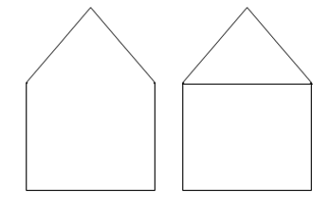

Then, it’s likely that you’ll need to figure out the length of some of the sides that have been created. In this example, the new line drawn on will be the same length as the bottom of the house. The height of the triangle could be found by taking the total height of the house and taking away the side length of the rectangle.

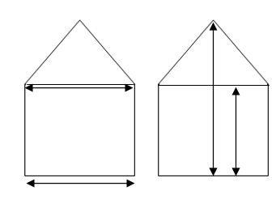

Then, find the area of the rectangle, and the area of the triangle, and add them together to get the total area of the house.

Steps:

1. Divide the shape into smaller, more familiar shapes.
2. Fill in any missing side lengths.
3. Find the area of each shape.
4. Add the areas together.

**Support**: Study Development offers workshops, short courses, 1 to 1 and small group tutorials.

* Book a tutorial or join a workshop on the [Study Development tutorial and workshop webpage](https://www.yorksj.ac.uk/students/study-skills/study-development-tutorials/) or search ‘YSJ study development tutorials.’
* Access our Study Success resources on the [Study Success webpage](https://www.yorksj.ac.uk/students/study-skills/study-success/) or search ‘YSJ study success.’