Area

Study Development Quick Guide

## Rectangles

Area of a rectangle = width $×$ height

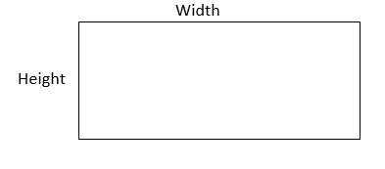

## Triangles

Area of a triangle = (base $×$ height) $÷$ 2

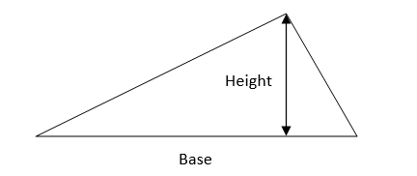

## Circles

Area of a circle = $π×{\text{r}}^{2}$

“r” is the radius of the circle (i.e. the length from the centre of the circle to the outside of the circle).

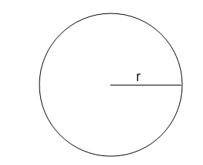

## Composite area

Steps:

1. Divide the shape into smaller, more familiar shapes.
2. Fill in any missing side lengths.
3. Find the area of each shape.
4. Add the areas together.

**Support**: Study Development offers workshops, short courses, 1 to 1 and small group tutorials.

* Book a tutorial or join a workshop on the [Study Development tutorial and workshop webpage](https://www.yorksj.ac.uk/students/study-skills/study-development-tutorials/) or search ‘YSJ study development tutorials.’
* Access our Study Success resources on the [Study Success webpage](https://www.yorksj.ac.uk/students/study-skills/study-success/) or search ‘YSJ study success.’