Area

Study Development Worksheet

## Questions

1. Calculate the area of a rectangle that has side lengths 3cm and 5cm.
2. How many m2 of carpet will be needed to carpet a room that is 10m by 6m?
3. Calculate the area of a triangle with base-length 30mm, and height 25mm.
4. Calculate the area of a circle with a 5m radius. Take $π$ as 3.14.
5. Calculate the area of a semi-circle with a 20cm base length. Take $π$ as 3.14.
6. 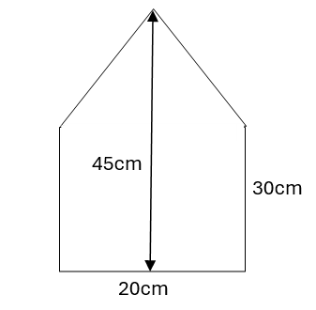I want to paint one side of a dollhouse (pictured below). The paint label says that one sample pot will cover 500cm2. How many sample pots should I buy?

## Answers

1. The formula for calculating the area of a rectangle is: width x length. In this case that is 3cm x 5cm = 15cm2.
2. 10m x 6m = 60m2 of carpet.
3. The formula for calculating the area of a triangle is (base x height) $÷$ 2.

So, this triangle’s area is: (30mm x 25mm) $÷$ 2 = 375mm2.

1. The formula for calculating the area of a circle is r2.   
   So, the area of this circle is: x (5m)2 = 3.14 x 25m2 = 78.5m2.
2. To find the area of a semi-circle, we find the area as if it were a circle, and then half that.

If the base length of a semi-circle is 20cm, then the radius would be half of that (10cm).

The area of the full circle is x r2 = x (10cm)2 = 3.14 x 100cm2 = 314cm2.

Now, we half this to get the area of the semi-circle: 78.5cm2 2 = 39.25cm2.

1. 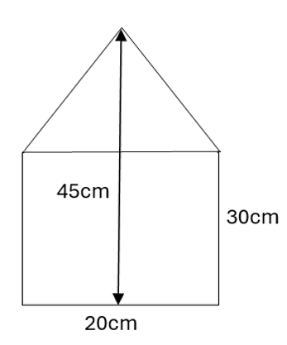This is a composite area question. To answer this, we split the shape into more familiar parts. Here, this looks like a triangle on top of a rectangle:

We find the area of the rectangle by multiplying the side lengths: 30cm x 20cm = 600cm2.

To calculate the area of the triangle on top, we need the base length and the height. The base length is 20cm (the same as the bottom of the rectangle). To find the height, we take away the rectangle height from the total height: 45cm – 30cm = 15cm.

Then, we find the area of the triangle: (20cm x 15cm) $÷$ 2 = 300cm2 2 = 150cm2.

Finally, we add the two together: 600cm2 + 150cm2 = 750cm2.

**Support**: Study Development offers workshops, short courses, 1 to 1 and small group tutorials.

* Book a tutorial or join a workshop on the [Study Development tutorial and workshop webpage](https://www.yorksj.ac.uk/students/study-skills/study-development-tutorials/) or search ‘YSJ study development tutorials.’
* Access our Study Success resources on the [Study Success webpage](https://www.yorksj.ac.uk/students/study-skills/study-success/) or search ‘YSJ study success.’