Interquartile range and box plots

Study Development Quick Guide

## Method

1. Place all the values in order from smallest to largest.
2. Find the median. For $n$ of data points, find the value in position $\frac{n}{2}+0.5$ (for example, for 5 data points, find the 3rd data point. This is the median). If $n$ is even, we find the values in positions $\frac{n}{2}$ and $\frac{n}{2}+1$ and find the point between them by adding them together and dividing by 2 (for example, for 10 data points, add together the 5th and 6th values and divide that by 2).   
   The median is called $Q_{2}$ (2nd quartile).
3. We are now left with two sets of numbers: those above the median, and those below. We find the median of each of these sets (make sure not to put $Q_{2}$ in either set before finding the median).
4. The median of the numbers lower than $Q_{2}$ is called $Q_{1}$ (1st quartile) and the median of the numbers higher than $Q_{2}$ is called $Q_{3}$ (3rd quartile).
5. The interquartile range (IQR) is given by $Q_{3}-Q_{1}$.

Interquartile range and box plots

Study Development Quick Guide

## Drawing a box plot

We can use the values for $Q_{0 }\text{(the minimum value)},Q_{1},Q_{2},Q_{3}$ and $Q_{4}$ (the maximum value) to draw a box plot (also called a box and whisker plot). These are useful for quickly seeing if data is skewed.

A box plot is drawn as follows:

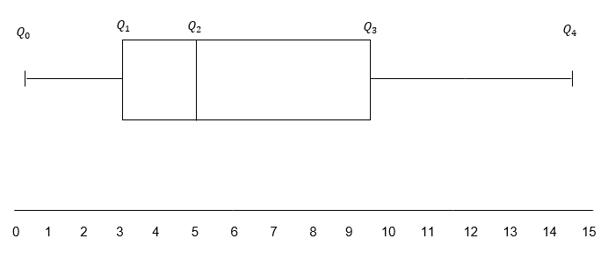

**Support**: Study Development offers workshops, short courses, 1 to 1 and small group tutorials.

* Join a tutorial or workshop on the [Study Development tutorial and workshop webpage](https://www.yorksj.ac.uk/students/study-skills/study-development-tutorials/) or search ‘YSJ study development tutorials.’
* Access our Study Success resources on the [Study Success webpage](https://www.yorksj.ac.uk/students/study-skills/study-success/) or search ‘YSJ study success.’